Backyarding has a purpose. What’s yours?
Copied from Texas Gardener Seeds Weekly online newsletter by the Outdoor Power Equipment Institute & TurfMutt Foundation

Backyarding — the trend to use the backyard for everything from tele-working and working out to relaxing and recreating — has a different purpose for each of us. Identifying your backyard’s role in your family’s health and happiness is the key to cultivating a purposeful outdoor space that is customized to your needs.

“How do you a create a more purposeful outdoor space? First, you need to identify what type of ‘backyarder’ you are,” explains Kris Kiser, President & CEO of theOutdoor Power Equipment Institute (OPEI) and the TurfMutt Foundation. “Then, you can get to work in your yard with that idea in mind.”

Here are just a few of the backyarding personality types. Which one(s) are you?
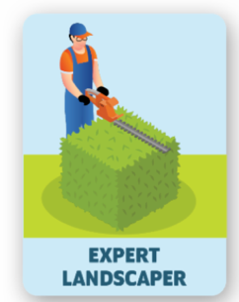
Expert Landscaper. Your yard makes neighbors green with envy. You know how to maintain a healthy living landscape all year long, and you have the latest outdoor power equipment to make even big jobs easier. Your idea of a good time? Spending the weekend doing yardwork. You love the sense of accomplishment that comes from working in your yard, and friends can count on you for advice about their own living landscapes.

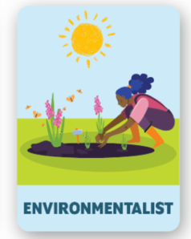
Environmentalist. You know that nature starts in your own backyard and that taking small steps in your yard can make a big impact on climate change. As the proverbial Robin to your yard’s Batman, you embrace your role in supporting the superhero powers of your living landscape (capturing and filtering rainwater, producing oxygen, and absorbing carbon just to name a few).

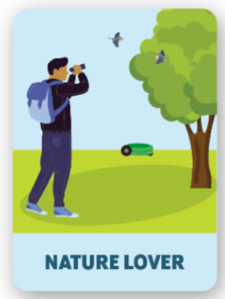
Nature Lover. No binging Netflix for you. You subscribe to “Nature TV” and prefer to spend your free time watching the birds, bats, butterflies and other wildlife that count on your yard for food and shelter. You cultivate a living landscape that supports a rich biodiversity with butterfly bushes, flowering plants, water sources, and trees and shrubs with nooks for nesting and food.

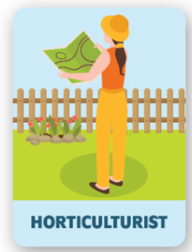
Horticulturist. The USDA Plant Hardiness Zone Map is bookmarked on your browser because putting the right plant in the right place is the living landscape Golden Rule you live by. You consider location, maintenance, sunlight and watering requirements, as well as your climate zone and lifestyle needs, before you even think about sticking your shovel in the dirt.

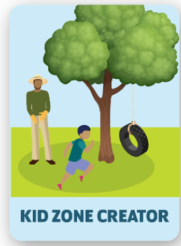
Kid Zone Creator. You know the safest place for your kids to be is in your own backyard, and you work hard to create an outdoor fun zone they will never want to leave. A flat area of sturdy turfgrass to play sports and pitch a tent? Check. Treehouse? Check. Zipline strung safely between backyard trees? Check. An elevated garden where they can help grow the family’s meals? Check. Natural playscapes, like a patch of sand bordered by rocks and log stump seating? Check. “Fun” is your middle name, and you are winning at this game.

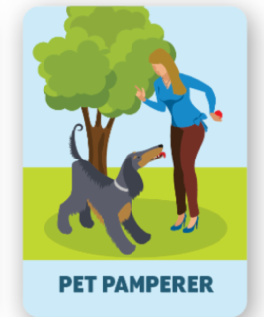
Pet Pamperer. Your focus is on Fido, and you take cues from your four-legged friends about how to purpose your backyard. You’ve planted sturdy turfgrass like Buffalo or Bermuda that can stand up to pet play, and you’ve used soft foliage to create a natural barricade between “off limits” areas and the rest of the lawn. Trees and shrubs are strategically planted for shade, and you’ve even set up a shallow water feature to help your pup cool off on hot days. Planting with purpose for you means keeping toxic plants out of the picture. (For a complete list, visit ASPCA’s list of non-toxic and toxic plants.)
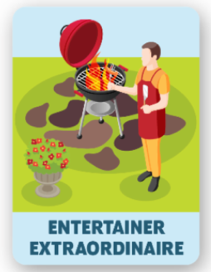
Entertainer Extraordinaire. Your backyard was the neighborhood hot spot long before the pandemic made that trend posh. Family milestones, birthdays, graduations, reunions, socially distanced BBQs — your yard is the place to gather. Your yard is set up for success with patio furniture, fire pit, yard games, plenty of outdoor seating, string lights, and maybe even an outdoor kitchen.

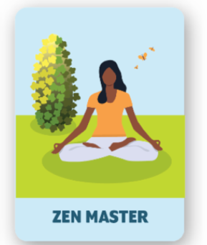
Zen Master. Enjoying your morning coffee on the balcony as songbirds serenade you. Meditating under the shade of a tree. De-stressing by swinging in a backyard hammock. Taking a break from your busy day to feel the sun on your face and the breeze in your hair. Your backyard is your sacred space for rest, relaxation and rejuvenation. You know that spending time outside is good for your health and well-being, and that thanks to your yard these benefits are only steps away.

https://www.aspca.org/pet-care/animal-poison-control/toxic-and-non-toxic-plants

