Signing into the Volunteer Management System (VMS)

To access VMS you will open up the link:

https://vms.texasmg.org
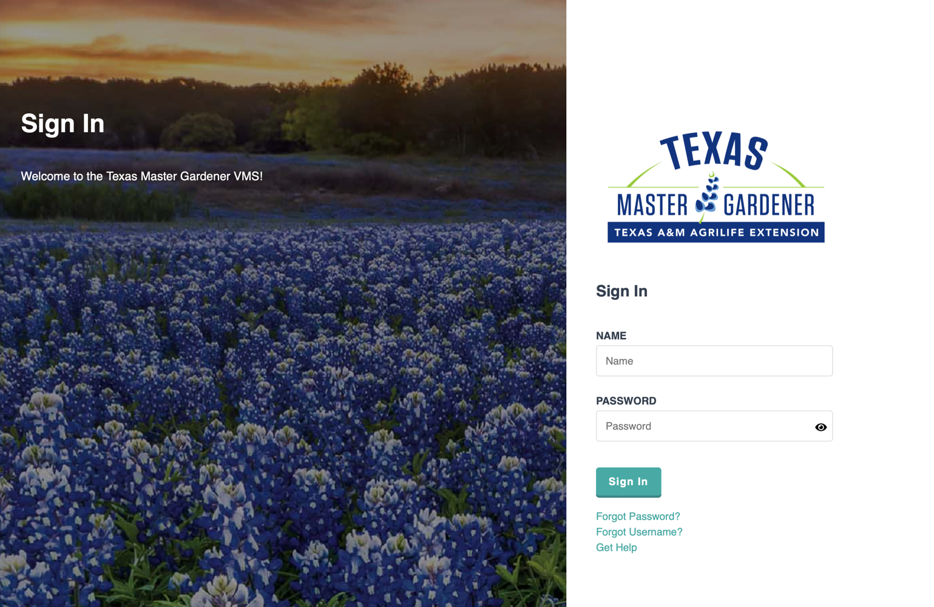

On this screen you will input your name from your email address without the any information after the “@”. For example if your email is johnsmith@gmail.com you will enter as your NAME – johnsmith. It should be in lower case letters.

Enter the temporary password provided to you in the PASSWORD space and hit “Sign In”.

Once you are logged into the system, the HOME screen will look like this:

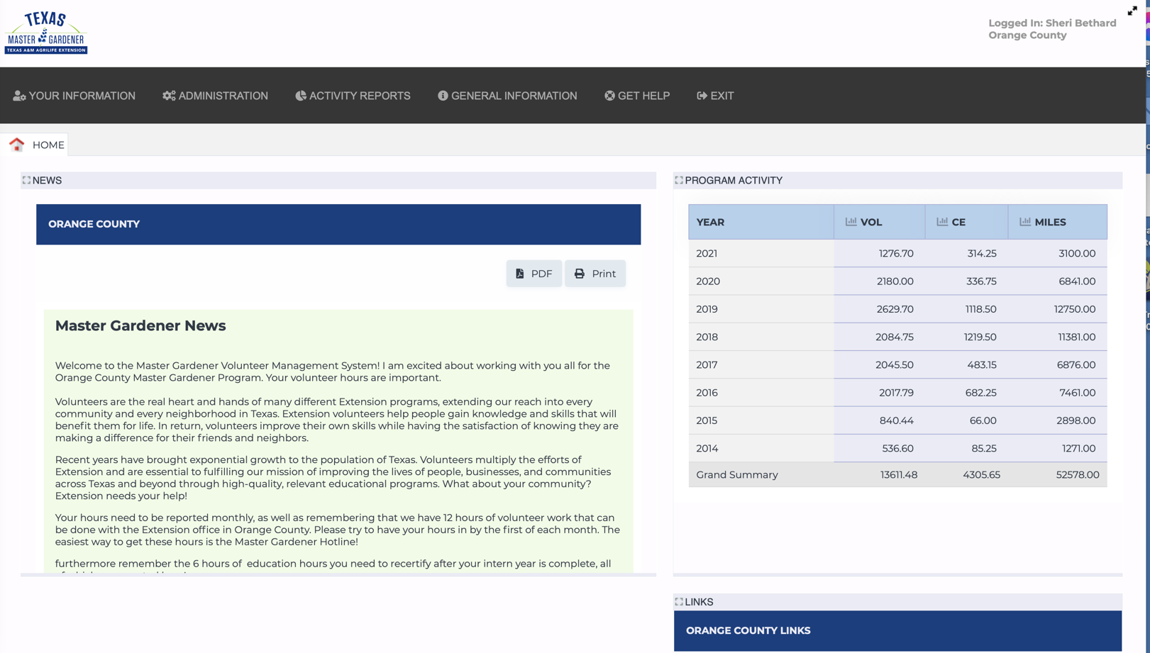
Your HOME screen will not have the tabs Administration or Activity Reports. They are for Staff, Agents and Coordinators only.

ON this screen, the Tab “YOUR INFORMAION” is where you will
edit your profile
reset password
add new hours
view your hours.

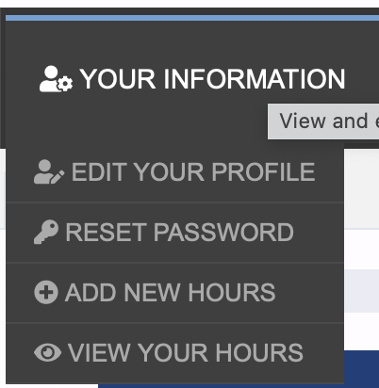

When you access EDIT YOUR PROFILE, your screen will look like this only your name will be inserted. You can go to each tab and make changes or add information.
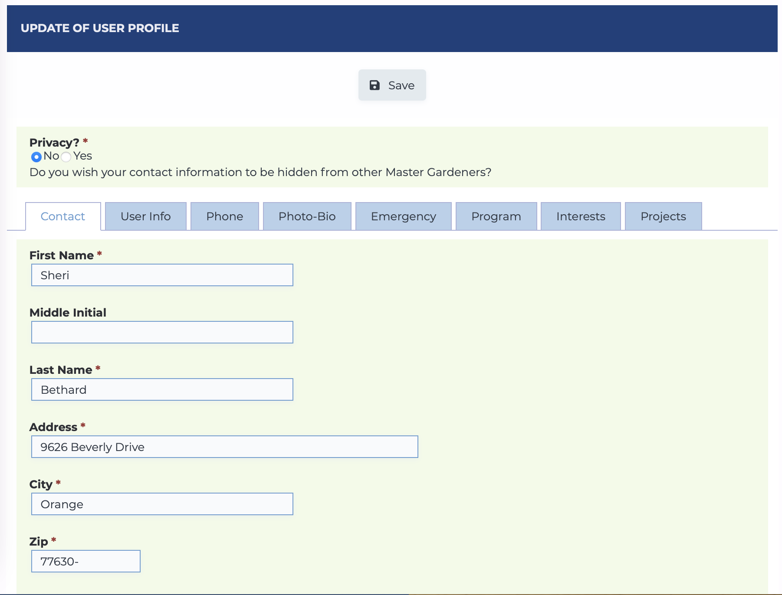
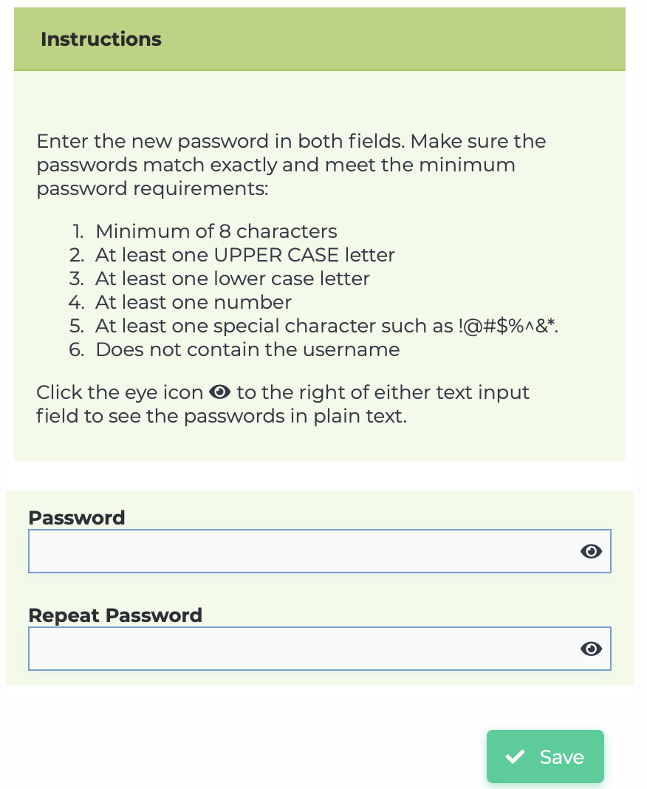

To Change your password, click on RESET PASSWORD and this screen will come up

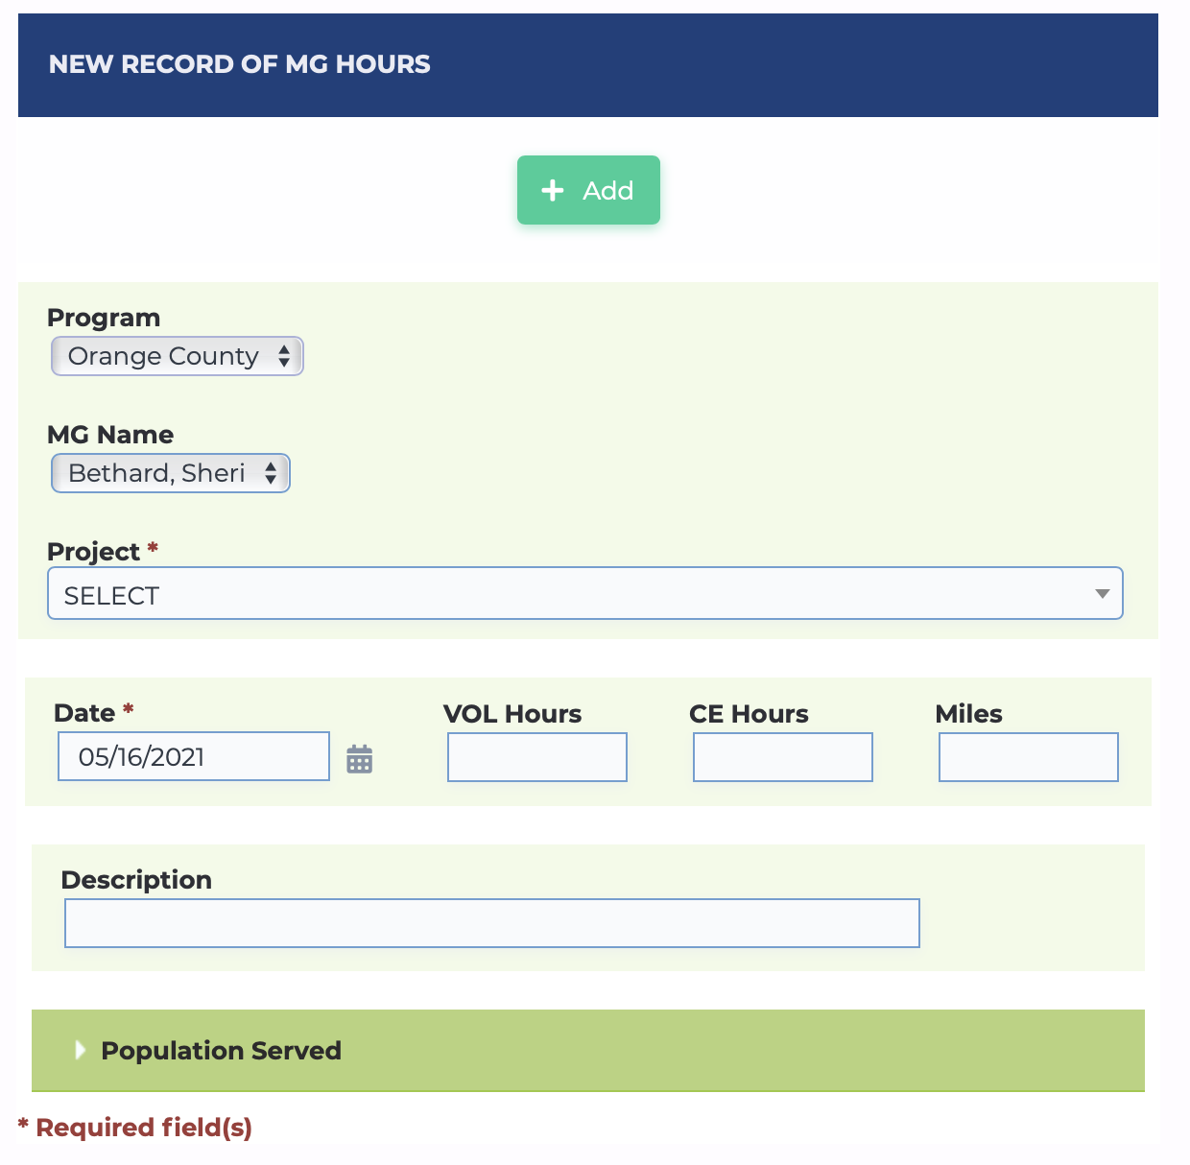
To Add hours to the system you will click on ADD NEW HOURS and the following screes will appear.

You will need to select a Project to which your hours will apply. For your Master Gardener training, you will select Master Gardener Training. (See attachment for explanation of Projects)

Next you will select the date, the default date showing is always today. Click on the calendar to the right and select the date of your hours.

Next, you will input the number of hours you spent. This is done in quarter hours: .25 (15 minutes), .5 (30 minutes), .75 (45 minutes). And regular numbers for full hours.
VOL hours = volunteer hours such as working at the greenhouse
CE hours = training hours such as Master Gardener Training.

Once you have entered all the information click on +Add and your time will be entered. The next screen will show your record was entered and will look like this or similar.
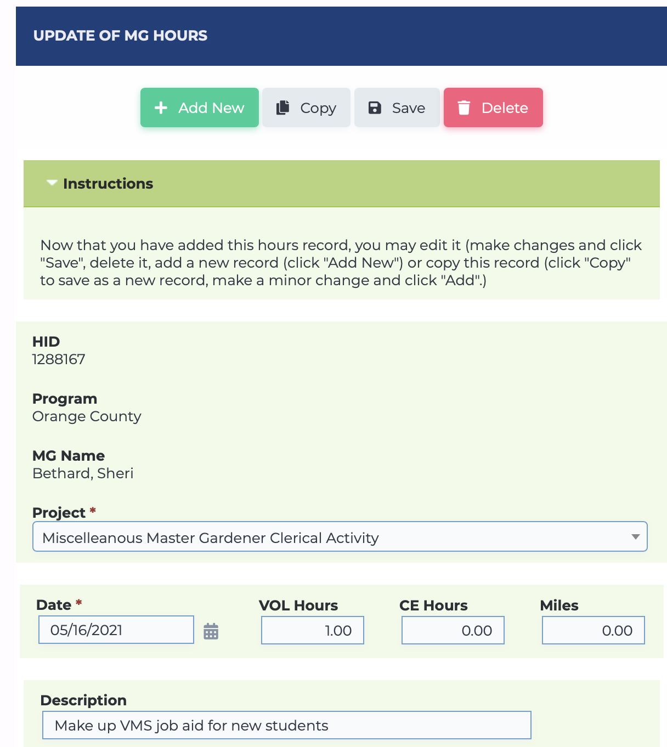

To add more entries – Click on +Add New and you will get the previous screen for adding more hours.

The VIEW YOUR HOURS tab will give a listing of all your hours.
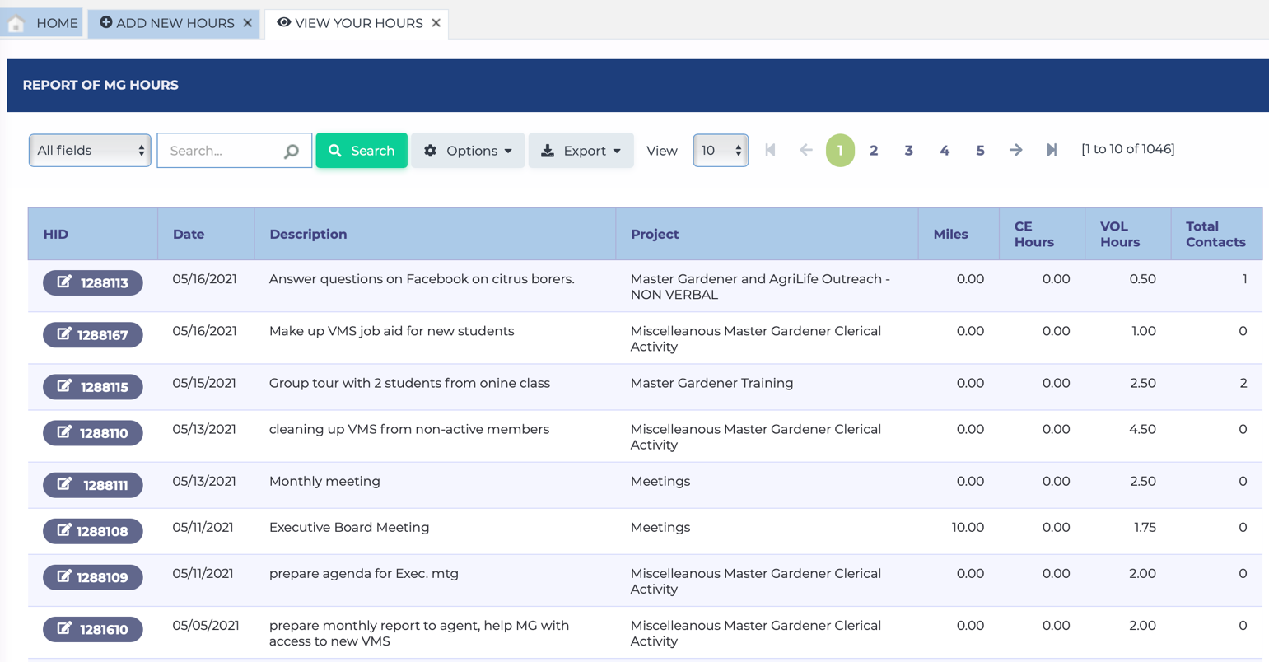

From this screen you can make any corrections you need to on any of your entries. Just click on the Blue Box on the left and it will bring up the UPDATE of MG HOURS screen and make what changes need to be done. Then click on “Save” and you will get a message saying, “Changes Saved”.

Under the tab “GENERAL INFORMATION” you will find the tabs:
MEMBER ROSTER
PROJECTS
DOCS/NEWSLETTERS

MEMBER ROSTER – Lists all the members in the Orange County Master Gardeners including Inactive, Leave of Absence, Staff, Certified, Trainee/Intern

PROJECTS – Lists all the Projects for our organization (see attachment) you choose from when in putting your hours.

DOCS/NEWSLETTERS – Any documents or newsletters can be uploaded here by the Agent, Staff or Coordinator.

GET HELP –
CONTACT SUPPORT
TUTORIAL VIDEOS

CONTACT SUPPORT tab is to send any problems you might be having with the system to the developer. Before you send a request for help, please check with your Coordinator or AgriLife Secretary as they may be able to assist you.

TUTORIAL VIDEOS – Videos are forthcoming regarding using the system. Currently there are two videos available to view. The first is for everyone and the second one is for Administrators, and you do not need to view.

EXIT - Clicking this tab will log you out of VMS and bring you to the login screen.

PROGRAMS & PROJECTS--

AgriLife Extension School Curriculum Enrichment Programs

School based curriculum enrichment programs of AgriLife Extension Service to enhance the regular school programs, JMG, school gardens, Learn, Go, Eat Grow, Better Living for Texas (BLT)

Community Gardens/Demonstration Gardens/Shangri La

Assist with the Field of Plenty Community Gardens or any other Community Gardens helping reach out to the less fortunate in our community about living healthier, learning how to grow your own food with very little, offering wholesome foods and opportunities to have available to them.

Volunteer at Shangri La Botanical Gardens, which serves to educate all walks of life about Master Gardeners, AgriLife, and the world around us. Any of the volunteer positions that directly impact the public will be considered Volunteer hours. i.e. Conductor, Theater Attendant, Bird Blind, Group Tour Guide, Boat Driver, NDC Attendant

Ed/Vol Time Outside OCMGA & TAM AgL

For educational and volunteer hours attended outside the Orange County Master Gardeners Association and Texas A&M Orange County AgriLife Extension Service location not listed in any other category, show them here. Keep the agenda or flyer for your records.

Master Gardener and AgriLife Outreach – NON-VERBAL

Dispersing Master Gardener and AgriLife materials such as Flyers, Newsletters, and other related materials around Orange County and surrounding areas to promote Master Gardener and AgriLife efforts. This is a regular task weekly at times to promote programs in all areas, Master Gardeners, AgNr, 4H, FCS, and BLT.
Updating the Master Gardener website and/or any social media website, i.e.
Facebook, articles to local newspapers with information promoting Master Gardeners

Master Gardener IN PERSON CONTACTS
Answer questions received from the public in PERSON in the AgriLife Extension office, while out in public or from family, friends, or neighbors
At local events, such as Art in the Park, Senior Rally Day, feed stores and the like, utilize Master Gardeners as a resource to promote Master Gardeners and AgriLife while helping answer questions related to horticulture.
Working with other organizations utilizing Master Gardeners as resources for horticultural knowledge while promoting the importance of Master Gardeners to the community.
Tally number of contacts in large event arenas if at all possible.

Master Gardener PHONE Helpline
Tuesdays and Thursdays from 10 am -2 pm, a volunteer will be available to answer questions received by the Extension Office answering horticultural questions received from the public by phone and walk ins. Along with helping the office staff with publicity, newsletters, etc. Thursdays will be the next staffed day when volunteers are available, and we will eventually have staff available Monday - Friday.

Be sure to tally your contacts.

Master Gardener Programs & Projects

Assist with the preparation and education of Master Gardener programs for the community and Master Gardener members.

Master Gardener Speaking Engagement
Time spent speaking to a group on behalf of Orange County Master Gardeners Association or Texas A&M AgriLife Extension Service Orange County.
Be sure to include the number of people in attendance in your contacts.

Master Gardener Training

This is a series of classes, which provides education to community participants and prospective volunteers.

If you are taking or monitoring a class - show as Education Hours

If you are teaching the class - show as Volunteer Hours and complete the profile at the bottom of the screen regarding the number of people and classification of the people.

New students in Initial Master Gardener Class will count their hours as Education hours to meet the minimum 50 hours instruction requirements.

To retain your Texas Master Gardener title, each member is required to participate in a minimum of 6 hours of education training and 12 hours volunteer time each year.

Meetings

Meetings pertaining to Master Gardeners Association, AgriLife, or Committees representing Master Gardeners or AgriLife within OCMGA or OC TAM AgL

MG Greenhouse & Plant Sale

Led by the OC Master Gardener Greenhouse Coordinator, the volunteers will work in the adjacent gardens, demonstration beds and the greenhouse with sowing seed, transplanting seedlings, repotting, taking cuttings, pruning, fertilization, irrigation, pest & disease scouting and control, mixing soil, cleaning nursery facilities, flats and pots along with a variety of other necessary tasks. They will also be needed in the gardens for weeding. The purpose of the greenhouse and adjacent gardens is to provide growth stock for the annual fundraiser plant sale and education opportunities for Master Gardener Interns, OISD students, JMG members and other community venues. Volunteers will be needed year-round for various duties with many of the volunteers needed from October thru Plant Sale time frame in mid to late spring.

The Annual Bloomin' Crazy Plant Fair is our annual plant sale held every spring. Volunteer time is counted when working to get plants ready for the sale when you are at your home or at the greenhouse. In addition, all preparation time setting up for sale is counted as Volunteer time.

Miscellaneous Master Gardener Clerical Activity

Any activity that does not fall into one of the other listed categories. Examples are balancing association checkbook, duties of officers, or any other clerical type activity, etc.

Other AgriLife Extension Educational Workshops, Projects, Committees and Events

Assist with the education in areas of Agriculture, Natural Resources, 4-H and Youth Development, Family consumer Sciences serving to improve the lives of our community members.

