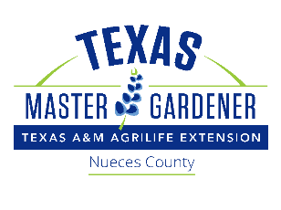
Nueces Master Gardeners
730 E. Main Ave., Suite 1
Robstown, TX 78380

Permission to Use Educational and Biographical Information and Photograph
Event: Master Gardeners’ High School Scholarship Program and Associated Events
Location: Del Mar College Economic Development Center, Student’s HS, and other locations associated with the NMG Intern 2021 Program.
I grant to Nueces Master Gardeners, Inc. and its affiliated organizations, the right to educational and biographical information and to take photographs of me and my family in connection with the above-identified event. I authorize Nueces Master Gardener Inc. and its affiliated organizations, its assignees and transferees to copyright, use and publish the same in print and/or electronically.
I agree that Nueces Master Gardeners, Inc. and its affiliated organizations may use such educational and biographical information and photographs of me with or without my name and for any lawful purpose, including for example such purposes as publicity, illustration, advertising, social media and web content.
I have read and understand the above:
Student Signature _________________________________
Printed name ______________________________
Address __________________________________
Date _____________________________________
Signature, parent or guardian _______________________
(if under age 18)
Printed name ______________________________
Address __________________________________
Date _____________________________________

