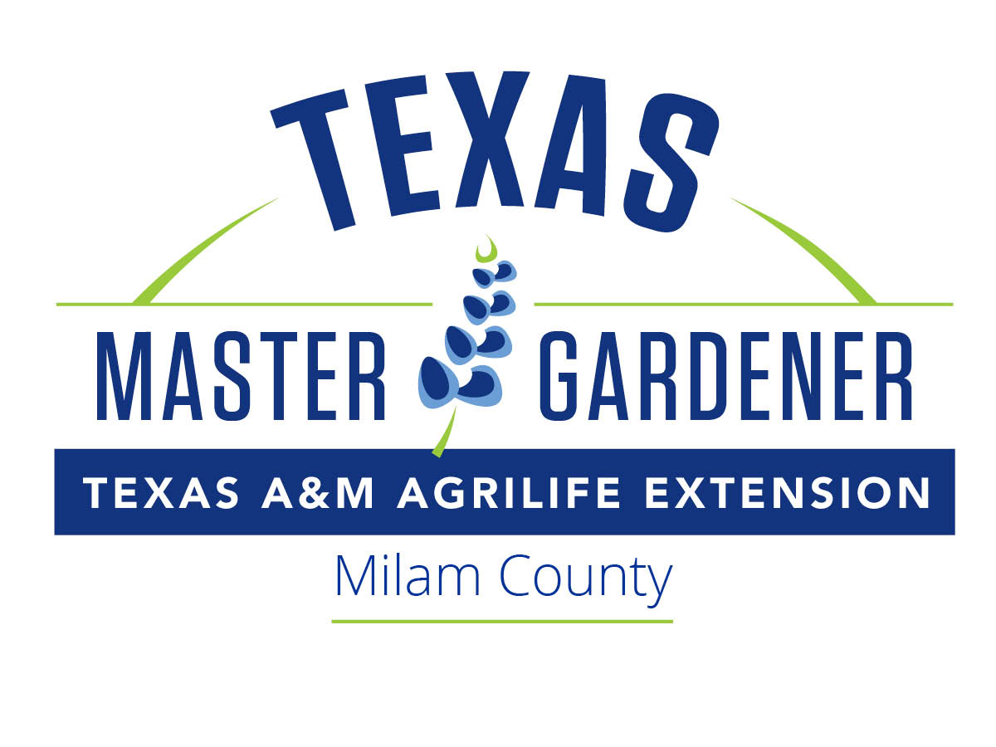
Little River Basin (Milam County)
Master Gardener Association

Who are the Little River Basin Master Gardeners?
The Master Gardener Program is a volunteer development program offered by Texas A&M AgriLife Extension Service and is designed to increase the availability of horticultural information and improve the quality of life through horticultural projects. The Little River Basin Master Gardeners are a diverse, local group who take an active interest in gardening and a search for knowledge. The program, which began in 2005, now has about 50 active members who have continued to update their training and volunteer hours each year.

Is the Little River Basin Master Gardener Program for me?
Do you want to learn more about the culture and maintenance of many types of plants? Are you eager to participate in a practical and intense training program (no tests)? Do you look forward to sharing your knowledge with people in your community? Do you have enough time to attend training and to complete the volunteer service? If you can answer yes to these questions, the Master Gardener program could be for you!

How do I apply?
Complete the attached Little River Basin Master Gardeners 2022 Training Application and the Texas Master Gardener Volunteer Agreement. Submit completed and signed forms, along with a check for $175 to Little River Basin Master Gardeners, AgriLife Extension Office, 100 East 1st Street, Cameron, TX 76520. Space is reserved on a first come, first serve basis. The program fee includes the training, class materials, and field trip admission fees.

Training Dates and Requirements
The training is to be held in the Chamber of Commerce Conference Room, 102 East 1st Street, Cameron, TX, from February through mid-May, with graduation mid-May. Classes meet from 8:30 a.m. to 1:00 p.m. each Wednesday, except for days when a field trip is scheduled. The program offers (and students must complete) a minimum of 50 hours of instruction that covers topics including lawn care, ornamental trees and shrubs; insect, disease and weed management; soils and plant nutrition; propagation; vegetable and herb gardening; home fruit production; garden flowers; and water conservation.

Volunteer Commitment
To become a certified Master Gardener, you must complete 50 volunteer hours by December 31st of your training year. The hours may begin during your training and are attained by working on approved projects, such as public education, Junior Master Gardener program, demonstration gardens, monthly member meetings, and the LRBMG plant sales. With the many opportunities available, meeting the volunteer hour requirement is not a problem for most participants.

Recertification
After initial certification, 6 hours of continuing education training, 24 hours of volunteer activities, and attendance of at least 4 meetings are required each calendar year.

Need more information on the 2022 class?
Contact Michelle Van Meter, Class Co-Coordinator, 713-817-7645 or md.vanmeter@yahoo.com
OR Aloma Clayton, Class Co-Coordinator, 512-760-6996 or alomac50@yahoo.com

Little River Basin Master Gardener Association (Milam County)
2022 Training Application

Name: ________________________________________________________________________________________

Address: _____________________________________________________________________________________

Email Address: ______________________________________________________________________________

Home Phone: ______________________________ Cell Phone: ___________________________________

Briefly explain why you wish to be a Master Gardener Volunteer:

Please tell us a little about yourself (career, volunteer work, skills, or whatever you wish to share):

______ Enclosed is my payment of $175, made payable to the Little River Basin Master Gardeners.

______ Enclosed is my signed Texas Master Gardener Volunteer Agreement.

Mail to:
Little River Basin Master Gardeners
Texas AgriLife Extension Service
100 East 1st Street
Cameron, TX 76520
Phone: 254-697-7045 (ask for AgriLife Office)

Texas Volunteer Agreement
Little River Basin Master Gardener Association (Milam County)

We appreciate your commitment to the Texas Master Gardener program. Your satisfaction and progress in this volunteer position are important to us. Please read the following expectations and indicate your willingness to cooperate by signing the end of this form. This form must be signed and filed with the county Extension office, and will need to be updated every three years. Volunteers not adhering to all items in this agreement may forfeit their certification as a Master Gardener volunteer.

I understand that I am trained by Texas A&M AgriLife Extension Service in the field of Horticulture and I am expected to extend research-based information to the public on behalf of Texas A&M AgriLife Extension. In exchange for the minimum of 50 hours of Master Gardener Training provided by Texas A&M AgriLife Extension Service, I will:
- Commit to a minimum of 50 hours of volunteer service to the horticultural programming efforts in Milam County within one year to become a certified Master Gardener.
- I understand that in order to maintain active status as a Master Gardener Volunteer, I must volunteer 24 hours annually after my intern year, attend at least 4 general meetings, and gain 6 advanced continuing education hours annually.
- Provide a record of this service as directed by the Master Gardener Program Coordinator.
- Comply with the Texas A&M AgriLife Extension Service Background Check policy. The background check is to be renewed every three years; however, enrollment in the online system is completed annually at the expense of the individual (about $10).

When acting as a Texas Master Gardener volunteer I agree to:
- Consistently exhibit a positive professional manner toward and about Texas A&M AgriLife Extension Service, the Master Gardener Program, the Master Gardener Coordinators, other Master Gardener volunteers and clients.
- Carry out and discharge all duties in a responsible and timely manner.
- Avoid conflict of interests
  - Not use my Master Gardener status to promote any commercial activity or private business.
  - Volunteer’s efforts for their place of employment will not be considered as volunteer service to Texas A&M AgriLife Extension Service.
- Recommend and use (when functioning as a Master Gardener) only Texas A&M AgriLife approved information for any public pesticide, herbicides, fertilizer or cultural practices.
- Provide my own transportation and pay my own expenses incurred as part of official volunteer activities. (Expenses may be tax deductible with proper documentation.) Some County Master Gardener Associations may assist volunteers with expenses to certain types of events. Check with your local Master Gardener Program Coordinator for more information on specific association policies and procedures.
- Act in accordance with the highest standard of ethics:
  - Not physically, verbally or sexually harass/abuse anyone
  - Refrain from illegal or unsafe behavior
  - Dress appropriately and not use harsh language
In regard to Master Gardener Coordinators, Master Gardener volunteers will:
- Recognize the responsibilities of the Texas A&M AgriLife Extension Service staff/ Master Gardener Coordinator in setting program priorities, standards and direction. Specific projects for the performance of the volunteer work are determined locally and should reflect local needs.
- Refer all commercial horticulture inquiries to the Master Gardener Coordinator or other Extension staff.

In regard to Master Gardener Colleagues, Master Gardener volunteers will:
- Welcome volunteers from all backgrounds
- Respect and safeguard the individual rights, competencies, safety, and property

In regard to Clients, Master Gardener volunteers will:
- Provide quality service to the public without regard to socioeconomic level, race, color, sex, disability, religion, age, or national origin.

I further understand that Texas A&M AgriLife Extension Service will:
- Provide training, supervision, and direction to Master Gardeners through the local county Extension office.
- Communicate expectations and responsibilities of the program to volunteers.
- Match volunteer skills and interests with volunteer opportunities within the county.
- Support Master Gardener volunteers and the local Master Gardener Association.
- Provide continuing education opportunities.
- Provide access to Extension horticulture reference materials and reasonable access to Extension professionals.
- Uphold and cultivate a trustful relationship between staff and volunteers.
- Reassign and/or terminate, if necessary, any volunteer who does not uphold Texas Master Gardener policies, procedures, guidelines, and/or values.

I understand that, as a volunteer, I will not be acting as a Texas A&M AgriLife Extension Service employee and will not receive pay or employee benefits. I also understand that I am not covered by workers’ compensation laws in connection with my volunteer affiliation. I understand and agree that Texas A&M AgriLife Extension Service and I both have the right to end my volunteer relationship with Texas A&M AgriLife Extension Service at any time, for any reason, and without advance notice.

Signature Date:

____________________________________________
Printed Name

[Information taken from: Purdue, Rutgers, Georgia, Wisconsin, Missouri, Illinois, California, & Texas (Montgomery Co.) Master Gardener Programs.]

