Landscape Design School Series XXVI, Course I
September 24-25, 2018

LOCATION: George Bush Presidential Library and Museum, College Station, TX
The George Bush Presidential Library at Texas A & M University will be the site of Landscape Design School I, September 24-25, 2018. The Schools are sponsored by Texas Garden Clubs, Inc. & the Texas AgriLife Extension Service, Texas A & M University. This course is popular with Texas Master Gardeners and can now be utilized by them for continuing education credit. Texas Garden Club Inc. and Texas A & M AgriLife Extension Service have sponsored this series from the 1960s onward.
Mrs. Diane Perez of Texas Garden Clubs, Inc. and Dr. William C. Welch, Texas AgriLife Extension Service announce the first in the current series which is offered in four separate schools, approximately six months apart, each with 10 hours of instruction, in the Bryan-College Station area. These courses offer an opportunity to learn from professional landscape architects and horticulturists about how successful landscapes are designed.
For this course our instructors will be:
Barbara Coody, MLA, will begin our program with “Development of Landscape Design”. Ms. Coody has a landscape design practice in the Brazos Valley. She will be teaching details of the early development Egypt, Greece, Persia, Rome, etc. as well as key components of landscape architecture from the medieval period, the renaissance, Italian and French influences and Muslim influence in Spain. In her next lecture, “Public Landscapes” she will speak on the role of designers in public space design and will cover the ideas of zoning, building and performance codes as well as the management and maintenance of public landscape spaces.
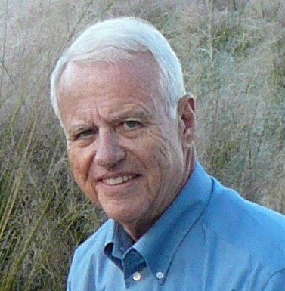
Pictured Above: Alan King, ASLA, Dr. William C. Welch, Bob Ruth ASLA, Dr. Whitney Griffin
Alan King, ASLA, is another local practicing landscape architect who is well known for his residential and commercial landscapes. In “Basics of a Site Plan” he will discuss the various methods to take simple site measurements. He will describe the mechanics of delineation, review the various symbols and other aspects of making and reading landscape plans.
Alan will explain computer-aided design (CAD) In his lecture, “Space, Design & People” and will discuss spatial structure, mass and void, and the three space-designing components: earth (mounds and grading), plants and structures.

Bob Ruth, ASLA will speak on “Developing Your Home/Private Grounds”. Bob will discuss the basics steps in planning a landscape including securing the plot plan/ determining easements, utility lines and underground wires, topographical features and plantings. He will Illustrate the importance of planning for the current and future needs of the family by preparation of a list of priorities.

Whitney Griffin, PhD, Dr. Griffin will lecture on “Design for the Environment.” She is a recent addition to our faculty who teaches graphic design and implementation of landscape plans. She is very popular with the students and brings a variety of professional experience to our faculty. Whitney will outline the execution of a design plan through sound site/planning practices with emphasis on plant ecology, indigenous materials, and reduction of energy consumption, sound water management practices, maintenance reduction, cost-effective design and implementation practices.

Sally Godfrey, RLA, ASLA will address the topic, “Landscape Design Resources”. She received her RLA degree from Texas A&M University and is a Brazos County Master Gardener. She will discuss the related design professions including the urban planner, landscape architect, architect, landscape designer, landscape contractor, the design/build professional and others in landscape design work, including horticulturists, nurserymen, landscape contractors and those at garden centers. She will discuss the extent of professional training required for each profession and their standards services and fees or methods of payment. She will detail their responsibility for public health, safety and welfare and briefly mention the use of professional registration and certification as a means of public protection.

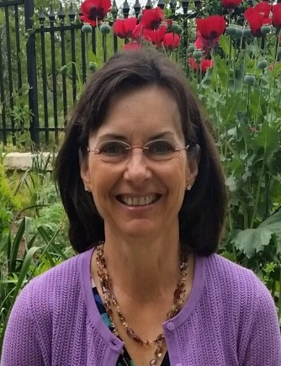
Pictured above are Dr Allen Owings, and Sally Godfrey, RLA ASLA
Allen Owings, Professor Emeritus-LSU Ag Center During his 25 years of service he provided statewide Extension programming for nursery growers, landscapers, garden centers and secondarily to Master Gardeners and home gardeners. He coordinated the Louisiana Super Plant Program. Dr. Owings is currently employed as Senior Horticulturist at Clegg’s Nursery in Baton Rouge and Bracy’s Nursery in Amite. He was born and raised in Hammond, LA and holds a BS degree (Plant Science) from Southeastern Louisiana University, MS degree (Horticulture) from LSU and PhD (Horticulture) from Mississippi State University.
He has been recognized by the Louisiana and National Agricultural County Agent’s Associations with their achievement award and distinguished service award. He is a life member of the Louisiana Nursery and Landscape Association and Louisiana Society for Horticultural Research. Dr. Owings belongs to numerous horticultural societies in LA and across the South. He is current President of the Louisiana chapter of the Azalea Society of America. He enjoys gardening, golf and LSU sports.
Dr. Owings plans to talk about “New Prospects for Landscape Shrubs, Annuals and Perennials”
At the end of the first day’s program participants are invited to a complimentary wine and cheese reception hosted by Stewart Thompson of Martha’s Bloomers Garden Center, Navasota. There will be an optional dinner opportunity after the reception. You will have an opportunity to sign up for these events during the first morning of the course.
Master Gardeners who complete a course and pass the test may apply to their MG Chapter to receive 12 hours of credit toward their requirements for continuing education. Texas Garden Club members who successfully pass the examination for all four courses are eligible to become nationally accredited Landscape Design Consultants. Texas Certified Nursery Professionals who pass the course may apply this to their requirement for recertification with the Texas Nursery and Landscape Association (TNLA)
Registration for the course will be $135.00 if paid by August 1, $145.00 by Sept 1 and $165 after Sept 1 , make check payable to Landscape Design School. Two lunches and snacks are also provided. The optional reference book, good for all four courses, is Stewards of the Land. It may be purchased for an additional $40.00 by February 1, 2018. The book will be reserved for participants to pick up the first morning of the course. The text is a reference for all four courses, although not required for graduation. The lectures will not be taken directly from the text. It is just another viewpoint of the material being presented. For additional details please refer to the Registration Form.
Registration materials and questions:
Mail to: Michele Wehrheim, Registrar
1218 Haines Drive
College Station, TX 77840
(313) 649-1067

Registration form may be obtained from:
aggie-horticulture.tamu.edu/southerngarden/

Questions: EMAIL Michele Wehrheim: texaslandscapedesignschool@gmail.com

NOTE: We will be communicating hotel information, event information and other last minute items by email. (If you do not have an email, we will mail it to you)

