₊
NEXT MEETING:
MAY 10, 1pm, BLANCO—BLANCO STATE PARK
May2016
Volume 21 issue 5

President’s Message 1
Did You Know 1
MG Calendar 2
Upcoming Events 2
Meeting Minutes 3
Hodge Podge 5
“Speaking of Birds… 6
“Wish You Were Here . . . 8
Plant ID 9
Garden To-Do List 10
Map for May Meeting 11
Internet resources 11

Educational programs of the Texas AgriLife Extension Service are open to all people without regard to race, color, sex, disability, religion, age, or national origin. The Texas A&M University System, U.S. Department of Agriculture, and the County Commissioners Courts of Texas are cooperating.

1955
President’s Message
Greeting all MGs,

Spring is here and leaving quickly. The tastes of summer heat have been amazing but give us reason to pause! What will the summer bring? Our weather is being a bit bipolar, hope it can even out soon.

I know everyone is in their gardens and the community gardens, so a quick reminder to stretch before and after, use good body mechanics and take breaks for water. Basic ideas but I know how quickly you forget and all of a sudden it is 2 hours later, you go to get up and whoa, your body is not happy! Our plants and flowers are wonderful things but so is your health. Be safe out there in the garden.

My world is spinning; hope to see lots of you soon.
Again, thanks for all of your hard work and help in our communities; we are making a mark in the area!!

Happy Gardening,
Bernadette

Astronaut Alan Shepard went on the first manned space flight, 1961
http://www.earthday.org/

20—Safety Day; Blanco

DID YOU KNOW??..
May Day—May 1 May Day has been a traditional day of festivities throughout the centuries in Europe. May Day is most associated with towns and villages celebrating springtime fertility (of the soil, livestock, and people) .
May 6—National Public Garden Day!!!-- In celebration of botanical gardens, arboreta, conservatories, educational gardens and historical landscapes, many of the American Public Gardens Association’s 590+ member institutions will mark the day with special events
May 30--Memorial Day--originated after the American Civil War to honor both the Union and Confederate soldiers who died in the war. The holiday was extended by the 20th century to include all American soldiers. Memorial Day is formally known as Decoration Day.

In the merry, merry month of
MAY

Sunday | Monday | Tuesday | Wednesday | Thursday | Friday | saturday
1 | 2  WORKDAY @ the “Y”  9-111 | 3 | 4 | 5 | 6 | 7
8 | 9 | 10  BCMG MEETING @  Blanco State Park at 12 | 11  Workday at The Settlement grass area | 12 | 13 | 14
15 | 16  WORKDAY @ the “Y” | 17 | 18 | 19 | 20  Workday at The Settlement grass area | 21
22 | 23 | 24 | 25 | 26 | 27 | 28
29 | 30  MEMORIAL DAY! | 31

May 10—Blanco MG meeting, 1:00pm, Blanco—Blanco State Park—Update on Cleanup

May 17-19—TEXAS State Master Gardener Conference
http://www.ccmgatx.org/txmg2016

May 20—Safety Day; Blanco County Fairgrounds

Master Gardeners of Blanco County
April 2016 Minutes

The April 12, 2016 meeting of Blanco County Master Gardeners, held at Johnson City UMC, was called to order by President Bernadette McFarling at 1:03 pm. All members present were reminded to sign in.
A motion was made by Margaret Becker and seconded by Becky Copeland to approve March meeting minutes. The motion passed unanimously.
TREASURER REPORT: Treasurer Joan Marasek reported a balance of $4,132.44. Copies of the 2016 budget were passed out to all present for review and approval. A motion was made by Shirley Winslow and seconded by Donna Norris to vote on approval of the budget. The motion passed by majority with one opposed.
VP REPORT: Vice President Alison Garza announced our May meeting and program to be held at Blanco State Park. Bring a sack lunch for a noon business meeting at the park pavilion to be followed by a tour to see and discuss what has happened in the park since the 2015 Memorial Day weekend flood. The park is waiving their day use fee of $4 for our group, so be sure to wear your Master Gardener name badge. You are also advised to dress comfortably and wear walking shoes for the tour.
The program being presented today by Lee Franzel and Carol Rankin on Home Canning is the first Master Gardener public presentation for 2016.
Bernadette asked for a show of hands of those planning to attend the State Convention in May.
COMMITTEE REPORTS
Gardenscape – Debbie Burkhard is still waiting on Blanco High School to schedule their homecoming before we can select our date. Carol Rankin spoke to a lady who wrote a book called “Garden to Table” and she is interested in attending. Debbie and Carol are meeting later today to discuss possible speakers.
Publicity – Brad and Lisa Bayliff ask that articles, news, events be submitted to them in a timely manner. All are encouraged to submit articles so that we have plenty of material to submit to the local papers and keep our name in the news. Bernadette thanked Brad and Lisa for their work on publicity for our group. It was also mentioned here that when an e-mail goes out to our members, a response of some kind is requested just so the sender can be sure you received the information.
Plant Sale – Our annual plant sale will be held on April 30 from 9 am to 2 pm at the City Park in Johnson City. Becky Copeland passed out a work schedule sign-up sheet. Set up begins at 7:30 AM. David Hamm and

Ray Stegall will take care of getting tables to and from the sale. Besides selling plants, we will be talking to people about Firewise, Rainwater Collection, Wildlife Drip Basins, and Plant Propagation. Becky Copeland prepared flyers that will be posted around Blanco and Johnson City and scanned for electronic posting. Joan Marasek will handle money and our license. Johnson City members who cannot get plants delivered early Saturday morning may drop your plants off at Betty Mucha’s home on Friday. Also, Becky Copeland offered to pick up plants on Friday. If you are unable to get them delivered to the park early Saturday morning, contact Becky.

NEW BUSINESS
David Hamm announced that the National Park will not maintain the grasses area at the LBJ Settlement in Johnson City. It is up to our group to keep those grass plots in good condition. He passed out a plot map and asked that we each ‘adopt’ one or more plots to clean, maintain and/or replant if necessary.

OLD BUSINESS
Per Carol Rankin, the group working on the Johnson City Community Garden does not want or need our help. There is, however, a second grade teacher in Blanco who needs help getting some plants and herbs planted so she can begin working on a grant for a teaching garden. Contact Carol if you are interested in helping with this project.

As there was no further business to discuss, the meeting was adjourned at 1:28 PM.

HODGE PODGE

The Blanco State Park beautification and invasive removal is about to start back up soon. If anyone would like to be added to the emailing list and isn't already on it, they can email me Olivia Sievers Ross with their information. Her email is osievers@gmail.com

Great article from Mother Earth News on Freezing Vegetables from your garden. Read it here:

http://www.motherearthnews.com/real-food/freezing/freezing-vegetables-zm0z13aszsor.aspx?newsletter=1&utm_source=Sailthru&utm_medium=email&utm_campaign=04.26.16%20MEN%20FP%20eNews&utm_term=FP%20eNews

Blanco Gardens

If you haven’t already noticed, Blanco Gardens is once again open for business!! Drop by and

say hello to Amelia!!

Spring Creek Gardens

Spring Creek Gardens opened in March of 2016. They offer a variety of trees, pottery birding and poultry supplies.

HELP NEEDED!

.
Diane Matthews a long time member lives in Fredericksburg. She needs someone to work once a week in her gardens. Pete from Blanco Gardens used to work for her. His failing health has left him to continue. dm1234@ctesc.net

“Speaking of birds…”
Article by Susan Evans

Aren’t you glad that spring is here? You are probably busy gardening while the weather is still mild. Well, the birds are busy, too. It’s nesting time! They have got to get those newly hatched chicks fed and ready to take on their new world before the heat sets in.
Speaking of birds, we live in one of the best spots in the whole U.S. to see the greatest variety of birds. Of the 914 species in North America, 621 have been seen in Texas. Some of the bird species, 338 to be exact, are migrants, spending their winters in the tropics of Mexico, Central or South America. These birds leave us in late summer and early fall to find better food sources during the winter months. They come back to us in the spring, funneling through Texas and fanning out to their summer homes in various parts of the US and Canada. We begin to see some of our neotropical migrants return in early March and continue through May. Our winter residents, like American Goldfinches, Pine Siskins and Cedar Waxwings leave to go back to their summer breeding grounds up North.
Already, we have seen the return of Ruby-throat and Black chinned hummingbirds. Some of these little guys face the enormous challenge of flying nonstop, 600 miles, over the Gulf of Mexico to South America. They travel this route twice a year, spring and fall.
The central location of the Texas hill country is a mix of several ecological regions, from desert scrub to riparian forests, which provides several distinct types of habitats favorable to a wide variety of birds. Over 431 species have been recorded. We are also on what is called the “Central flyway”. That means that many of the migrants have to pass through our area on their way to their summer breeding grounds or their winter homes in the Tropics. In April and early May, birders from all over the world come to Texas, particularly along the Texas coast, to see birds return to the US from their winter homes. Large, mixed flocks of songbirds, warblers, hawks, shorebirds and many others stop briefly to gorge on local cuisine before moving on. Few places in the world offer the opportunity to see so many species of birds in one place at one time. We can see some of those birds in our own back yards if we are vigilant.
I put out oranges and grape jelly for Baltimore Orioles when they pass through. I also listen for Warblers. They like to glean bugs out of the tops of trees. They move fast and don’t offer a lot of viewing time so you have to listen and be ready with your binoculars.
One of the most beautiful of those returning bird species that makes its home in the hill country is the Painted Bunting. They will be arriving in mid April. They are seed eaters so be sure to include millet in your bird feeders, a favorite food of the Buntings. Another of my favorites is the Summer Tanager. The male is all red and is often mistaken for a Cardinal. Although roughly the same size, he has no black mask and his beak is built for catching insects, not eating seeds, so they do not come to your feeders.
As Master Gardeners, we can provide some kind of ibitat with native and adapted plants that produce flowers and seeds that benefit our birds, butterflies and other wildlife. We can also provide additional food with our feeders so we can enjoy seeing the birds that come to them
So, here’s to the bounty of spring and all her lovely returning children!
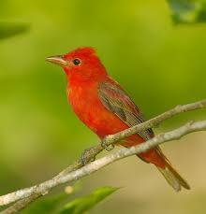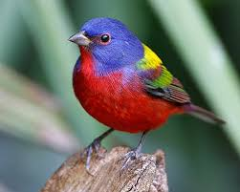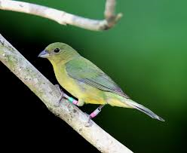
Female painted bunting
Painted Bunting
Summer tanager

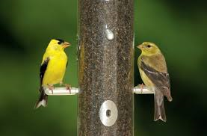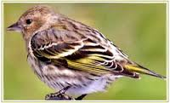
Pine suskin
American goldfinch: male and female

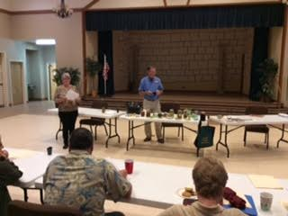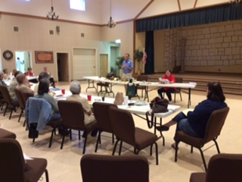
“WISH YOU WERE HERE….Canning with Lee”

Top left President Bernadette McFarling introduces speaker Lee Franzel to the group (2) An explanation of various components used to properly preserve vegetables, pickles and salsa was presented by Lee at the April meeting.

Comal County Master Gardener, Lee Franzel, presented the BCMG group with some valuable information on canning. He included a handout with basic canning supplies and procedures. Along with this handout, our own Carol Rankin provided a handout with some of our group’s favorite canning recipes and a very informative handout about canning terms, processing times for various vegetables and food stuffs, common problems and a seasoning guide. A door prize was awarded to one of the public attendees.

PLANT IDENTIFICATION
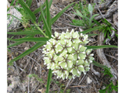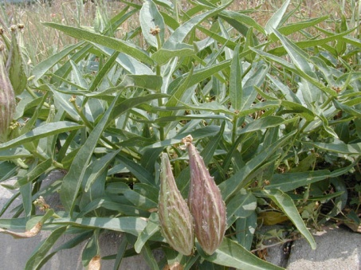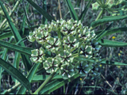

Common Names: Antelope horn milkweed, Green-flowered milkweed
Scientific Name: Asclepius asperula Family: | Asclepiadaceae
Description: clump-forming, 1-2 ft. perennial with an upright or sprawling habit. Stems are densely covered with minute hairs. The leaves are 4-8 inches long, narrow, and irregularly grouped. The long, thick, narrow leaves are often folded lengthwise. As the green seed follicles grow in length and begin to curve, they are said to resemble antelope horns, thus one of its vernacular names.
Leaf: long, thick, narrow leaves, often folded lengthwise.
Leaf description: alternate, simple, pinnate
Fruit Type: Follicle
Requirements: light: sun; soil moisture: dry, moist; prefers rocky or sandy soils

Maintenance: minimal, deer resistance:high
Local Location: meadows, along roadsides, well-drained caliche, loam, sand, lay
Wildlife: Butterflies, Larval Host for Monarchs, Queens, special value to native bees, bumblebees, honeybees
Propagation: Seeds, Root cuttings can be taken in fall or early spring. Seeds may be sown outside in late fall or the following spring. Germination of spring-planted seeds is enhanced by moist stratification.
***Seed Collection: Collect seed in June.
Seed Treatment: Stratify 3 months at 40 degrees. Germinates best in warmer half of the year.
Sources: LBJ Wildflower Center, Texas Native Ornamental Trees by Native Plant Society of Texas, and PlantAnswers.com;
Submitted by Donna Norris

From the Comal County Gardening Guide:
  - May—time to do some harvesting and garden cleaning after spring. Look for insects and disease. Fertilize now if you have not already done so.
  - Tomatoes may be harvested when they start to turn from green to pink—don’t let the bugs have first shot at them.
  - Harvest potatoes—do not wash them, dust them off, store them and wash when you cook them
  - FERTILIZE!!vegetables need fertilizer to generate growth after first fruit sets, then every three weeks thereafter.
  - Monitor onions. When tops all over, pull them and let them lie on the earth until dry.
  - May is a good time to plant okra, southern peas, sweet potatoes pumpkins, watermelons
From the Farmers’ Almanac: April 2016
1st-2nd Fine for vine crops. Set strawberry plants. Good days for transplanting. Favorable time for planting late root crops.
3rd-4th Poor planting. Fine for cultivating or spraying.
5th-6th First day is a good day for transplanting. First day is also when planted root crops will yield well. Second day is favorable for planting beans, corn, cotton, tomatoes, peppers, and other aboveground crops.
7th-8th Any seed planted now will tend to rot.
9th-10th Plant seedbeds and flower gardens. Most favorable for corn, cotton, okra, beans, peppers, eggplant, and other aboveground crops.
11th-15th A barren period. Favorable for killing plant pests, cultivating, or taking a short vacation.
16th-18th Favorable time for sowing hay, fodder crops, and grains. Plant flowers. Excellent time for planting corn, beans, peppers, and other aboveground crops.
19th-20th Plant seedbeds. Excellent for planting aboveground crops, and planting leafy vegetables.
21st-23rd Seeds planted now will do poorly and yield little.
24th-25th Plant late beets, potatoes, onions, carrots, and other root crops.
26th-27th Kill plant pests on these barren days.
28th-29th Fine for vine crops. Set strawberry plants. Good days for transplanting. Favorable time for planting late root crops.
30th-31st Poor planting. Fine for cultivating or spraying.29th-30th Excellent time to kill weeds, briars, poison ivy, and other plant pests

Map to the May Meeting
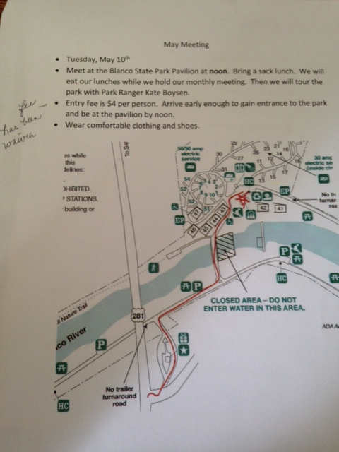

INTERNET RESOURCES (a few, there are hundreds!!)
Aggie Horticulture http://aggie-horticulture.tamu.edu/
Central Texas Gardener, KLRU-TV http://www.klru.org/ctg/
Texas Gardener, the Magazine http://www.texasgardener.com/
Mother Earth News http://www.motherearthnews.com/

