March 2016
Volume 21 issue 3

President’s Message 1
Did You Know 1
Upcoming Events 2
MG Calendar 2
More events 3
Meeting Minutes 4 Hodge Podge 7
Pictures of . . . 8
Plant ID 9
Garden To-Do List 10
River Restoration 11

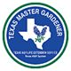

Educational programs of the Texas AgriLife Extension Service are open to all people without regard to race, color, sex, disability, religion, age, or national origin. The Texas A&M University System, U.S. Department of Agriculture, and the County Commissioners Courts of Texas are cooperating.

NEXT MEETING:
MARCH 8, 1pm, Dripping Springs

DID YOU KNOW…?

The word shamrock comes from the Gaelic word Seamrog, meaning “little clover”. A clover is the commonly used name for any number of plants belonging to the genus Trifolium, meaning “having three leaves.” Even among botanists, there is some disagreement on what species is the “true” shamrock, but most agree that the White Clover is probably the original shamrock of Irish symbolic heritage. While trying to convert the Irish into Christians, St. Patrick used the shamrock to explain the holy trinity with each leaf representing the Father, Son and Holy Spirit.

https://www.tenontours.com/irish-culture/difference-between-a-shamrock-and-a-four-leaf-clover/
President’s Message
Greetings,
We are experiencing spring in February????? This weather is so perplexing; we all know we will have a late freeze. (Please?)
Plans are well underway for the April plant sale; maybe this weather has helped those propagations along. We should all have little plants growing! Plant those seeds!!!
Please email me if you want to have a spot at the plant sale to provide educational opportunities to the community. D’Anne and Pat have already expressed interest in mini seminars to educate the public about their specialties. Anyone else? Just call or email me.
The outreach committee is dedicated to getting the word out to the public on all our upcoming events. I know that their hard work will provide us much success.
I am not sure I will be at the meeting on the 8th, if my surgery on the 24th of Feb takes too much of my energy I may stay home and sip! I will do my best! If anyone makes a delicious clear liquid I would love to try it, this clear liquid diet after surgery will be a challenge!!
Thanks for all your hard work,
Bernadette

Bernadette

March 5—Saturday—Blanco River Restoration Workshop—Wimberley Community Center (see flyer)

Contact info: ryan.mcgillicuddy@tpwd.texas.gov

March 8—Monthly Meeting at 1 pm in Dripping Springs: Orchid Tour, email directions to follow

March 10-- LBJ Medical Center in Johnson City at 11:30a.m., cleaning flower boxes

March 10—Molly Keck—“30 Bugs Every Gardener Should Know” (see Hodge Podge, pg 6)

March 15-17—Austin Spring Home and Garden Show, Palmer Events Center, Austin
https://tradeshowz.com/austin-spring-home-and-garden-show

April 12—Monthly Meeting, 1pm, Johnson City, Presenter: Lee Franzel, topic: Canning

April 30—Plant Sale—get your seeds planted!!

May 17-19—TEXAS State Master Gardener Conference
http://www.ccmgatx.org/txmg2016

May 20—Safety Day; Blanco County Fairgrounds
MARCH 2016
Sunday | Monday | Tuesday | Wednesday | Thursday | Friday | Saturday
 |  | 1 | 2 | 3 | 4 | 5
6 | 7 | 8  MG MEETING  1:00  Dripping Springs | 9 | 10 | 11  WORKDAY!  Settlement –grass area | 12
13 | 14 | 15 | 16 | 17  St. Patrick’s Day | 18 | 19  Workday at the “Y” 9-11
20 | 21 | 22  WORKDAY!!  Settlement-grass area | 23 | 24 | 25 | 26
27 | 28 | 29 | 30 | 31

MORE MARCH EVENTS!!
March is certainly a busy gardening month. I have included events Susan sent me from various places around Marble Falls. Backbone Nursery is presenting many seminars on Saturdays in March. See the following list:

"Growing and Using Herbs" with Sherie Clarkson will be on Friday, March 4th. This free program is presented by the Kingsland Garden Club at the Kingsland Library, 125 W. Polk. The public is invited to the program which starts at 1:30. Everyone is invited to the Club meeting at 1 PM. Click for Garden Club page AT credit for MG
n Saturday, March 5th, Backbone Valley Nursery will present a free program “All About Herbs” with Trisha Shirey. Program is at 1 P.M. at Backbone Valley Nursery, 4201 FM 1980. Backbone Valley events page AT credit for MG

We have two free Green Thumb Programs on Wednesday, March 9th.
Rosalyn Lackey, Master Gardener, will present "Propagation 101: Growing New Plants In Properly Treated Soil And Making those Pesky Insects Go Away", 10:30 to 11:30, at the Bertram Library, 140 S. Gabriel St., Bertram and Violet Carson, Master Gardener, will present "Tomatoes And Their Kind" at 12:00-1:00, at the Kingsland Library, 125 W. Polk, Kingsland Click here for more Green Thumb info AT credit for MG on both programs.

On Thursday, March 10th, Master Gardener Sheryl Yantis will present an interesting and informative program "Butterflies - The Jewels of Our Garden" at a meeting of the Highland Lakes Garden Club at 1:00 PM at the Marble Falls Library. The public is invited. More info here. AT credit for MG

Backbone Valley Nursery will present free workshops and seminars each Saturday in March. All start at 1 P.M. at Backbone Valley Nursery, 4201 FM 1980. All are approved for AT for Master Gardeners.
Saturday, March 12th “Tomato Growing Seminar with Jessica”
Saturday, March 19th “Vegetable Gardening 1 (soil prep.) with Andy of Fox Farm Products”
Saturday, March 26th “Vegetable Gardening 2 (planting) with Jessica”

The Texas Bluebird Society will present the 2016 Season Kickoff and FUNdraising Auction in Bastrop on Saturday, March 12th. The annual kickoff promotes the conservation of bluebirds and teaches the public how to attract and provide quality habitat for bluebirds across Texas. 9 AM to 3 PM Guest speakers will cover topics that bluebirders, new and experienced, will find interesting and entertaining. Get full information at http://www.texasbluebirdsociety.org/2016event.php

The Native Plant Society is proud to present Amy Sugeno, LCSW, biologist and ecotherapist (nature-based therapies for adults and children) who will speak on the healing benefits of plants and gardens. The public is invited to attend on Saturday, March 19th at 1:30 at the Marble Falls Library Click here for more info about this interesting program. AT credit for MG

If you know of a high school senior or college student studying horticulture or agriculture, you will want to check out the Highland Lakes Master Gardeners 2016 Scholarship Program. Click here for full information on the program.

We are all looking forward to the Hill Country Lawn and Garden Show which will be on Saturday, April 2nd this year at the Burnet Community Center. Click here for map and more information.

You can also check out upcoming gardening events and access other interesting pages at www.yantislakesidegardens.com/events

Master Gardeners of Blanco County
February 2016 Minutes

The February meeting of the Master Gardeners of Blanco County was held at First United Methodist Church in Johnson City. President Bernadette McFarling called the meeting to order at 2:26 PM on February 9, 2016 following a program on “Hummingbird Hot Spots” by Kathleen Scott of the Comal County Master Gardeners. January’s minutes were approved as written.

President’s Report
President Bernadette McFarling announced that an updated member list is in the works. If you have not provided and/or updated your contact information, please send it to Donna Norris as soon as possible. If you have a project, etc., to present at one of our monthly meetings, please put those details on paper and provide a copy to Secretary, Margaret Becker, for recording.

Treasurer’s Report
Treasurer Joan Marasek reported the account balance at $4300.58. She said that an order had been placed for 50 of our books and they should be arriving soon. Shirley Winslow announced that Master Gardeners, as a non-profit group, were eligible to apply for a grant from Wild Woman Weekend. Deadline is March 15. More information can be found online.

Vice President’s Report
VP Alison Garza announced a change to original meeting plans for March. It will still be held on March 8 at 1 PM, but we will be taking a field trip to Dripping Springs to the home of orchid grower, Maddy Verret. A map with directions was handed out and an e-mail with this information will follow. Please try to carpool as parking will be limited. The home canning program, presented by Comal County MG Lee Franzel, has been moved to April and will be open to the public. Refreshment volunteers are needed for this event to be held at the First United Methodist Church in Johnson City at 1 PM on April 12. Carol Rankin is requesting your favorite home canning recipes for a handout she will prepare. Please e-mail them to her.
There are still some refreshment volunteer slots that need to be filled. Please contact Alison if you can help with refreshments for one or more meetings this year.

COMMITTEE REPORTS
The Publicity Committee, led by Brad and Lisa Bayliff, is working to create more awareness of Blanco County Master Gardeners and a greater community presence. Events and activities will be grouped into 3 categories: VIP, Minor, and Every day. One of their goals is to have a Master Gardener article published in the local newspapers each month. Any special event announcements for the newspaper require a one month notice. The

committee’s plans include opening three of our meeting programs to the public, participation in community parades, and posting signs at projects created and/or maintained by Master Gardeners. The signs would include a QR code that could be scanned by any smart phone to provide more information and a link to our website. Also, an official Blanco County Master Gardener letterhead has been designed by Donna Norris.
Carol Rankin reminded us that blank Master Gardener business cards are available at the Extension Office. You can add your name and hand them out to anyone interested. If you are a member of any other community organizations, please remind your group that there are Master Gardener Specialist speakers available for presentations.
The Book Sales Committee, led by Susan Hamm, has plans to begin promoting sales of the 50 books that will be arriving soon.
The Plant Sale Committee chairman was not present, but Bernadette McFarling encouraged everyone to get their plants growing for the plant sale on April 30 at the Johnson City Park on 290. Our sale will NOT be held in conjunction with the monthly market day this year. It was suggested that our Specialists present some seminars throughout the day. Pat Owens volunteered for rainwater collection.
The Gardenscape Committee, led by Debbie Burkhard, said she is waiting on Blanco High School to set their Homecoming date before finalizing a date for the 2016 Gardenscape. Once a date is set, we can begin to solicit speakers and vendors. The 2015 Gardenscape “FUN”damentals was submitted by Jim Meadows and Carol Rankin to the state for event judging. Awards will be announced and presented at the state convention.

PROJECTS – Current and Past
A calendar has been created for all Master Gardener activities, including work dates on current projects. It has been well received. These items were mentioned: Wednesday, 2/10, from 9-12 at the JC Welcome Sign - weeding and planting bluebonnets. Friday, 2/19, at 10 AM at the JC Water District Office - a planning meeting for that project. For additional workdays, see the calendar.
Susan Hamm discussed two past MG projects that she feels should be revisited: The LBJ Native Grasses Area in Johnson City and the Blanco County Crabapple Project.
Grasses Area - Russ Whitlock has ordered making the grasses area a priority and is asking for a pamphlet on the grasses which would identify and describe each of them. We need to locate the original paintings of the grasses done by Susan Evans and a volunteer to create the pamphlet.
Blanco County Crabapple – This tree is nearing extinction due to deer. Years ago several members acquired and planted them in an effort to save it. Susan stated that this could be a very important and worthwhile research project for our Master Gardeners to pursue. Volunteers are needed to map where the trees are, photograph and measure them. Lighting, soil, and growth rate should be recorded. In addition, new trees should be planted to prevent extinction.
Susan feels that these two projects are very important for our group and our county.

NEW PROJECTS
YMAC Community Garden – Carol Rankin and Debbie Burkhard are seeking volunteers who will join with them to assist in the planning of the YMAC Community Garden. Bernadette suggested that Carol send out an e-mail for helpers.
LBJ Nursing Home Planter Boxes – Carol Schlachter requested $114.60 to purchase soil and plants for revitalizing the wooden planter boxes at the LBJ Nursing Home and made a motion that we approve the expenditure. It was seconded by Henrietta Smith and approved by majority. In keeping with new plans to let folks know what we are doing in the community, a small sign and QR code will be placed at the project when it is completed.

GENERAL BUSINESS
Chris Weimers announced that Blanco County has been selected for the pilot program offering Master Gardener certification online. Its main purpose is to allow people to take classes whenever they can instead of only every other year, or in some counties, as seldom as every three years. It also allows people who work full time to take classes at their convenience. There are still many unanswered questions and details to confirm. Our greatest concern is whether or not we will need to plan a 2017 class of our own as has been done in the past. More information will be shared as it is known.
Bernadette McFarling announced that Chris is working on getting a storage area for our group – possibly in the old Extension Office. Debbie Burkhard voiced concern about that because the Friends of the Library are currently operating a thrift store in a portion of that building, but have insurance on the entire building. Details will need to be negotiated and hopefully an agreement can be reached. More information will be forthcoming.
After many years of outstanding service, Ann Cook will no longer be tracking AT and Volunteer hours. The new Membership Chairman is Jane Brandenstein, so be sure to get your hours to Jane as soon as possible each month. It is VERY important that we track and report ALL hours.

BITS AND PIECES
The State Convention will be held in Collin County this year. Attendance is encouraged.
Our very own Jim Meadows was pictured in the February issue of Texas Coop Power Magazine which, even though our MG group was not mentioned, contained a good article about Texas Master Gardeners. It was suggested we invite the author to Gardenscape so that she is aware of the presence and vitality of the Texas Master Gardeners of BLANCO County!
As there was no further business to discuss, the meeting was adjourned at 3:11 PM.

Respectfully submitted by Margaret Becker

HODGE PODGE

Flower Boxes
On Thursday, March 10th, we will meet at the LBJ Medical Center in Johnson City at 11:30a.m. to clean up the ten flower boxes that sit outside the windows. We will clean up existing soil, add a few nails/screws to improve the boxes, add some new soil and plants and then water and go. This should not take more than an hour or two. Please bring gardening gloves, small gardening tools and money for lunch afterwards. All are welcome. Please RSVP to Carol Schlachter at 830-456-4322 or see her at the March 8 meeting in Dripping Springs.

It’s Official!!

The intern class of 2015 received their Master Gardener name badges at the February meeting!!
Congratulations to: Brad Bayliff Debbie Burkhard
Lisa Bayliff Alison Garza
Dan Brandenstein Donna Norris
Irene Broussard Ray Steagall
Molly Keck –Get a head start on what bugs will likely be bugging you in your garden.
“30 Bugs Every Gardener Should Know”
March 10, 2016
10 am – 12 pm
$10
Extension Office
3355 Cherry Ridge, Suite 208, San Antonio, TX

March Meeting Refreshments will be brought to you by. . .
Susan Henrichson
Becky Copeland
Thank you for signing up this month!

Pictures of our MG Hard at Work!!!

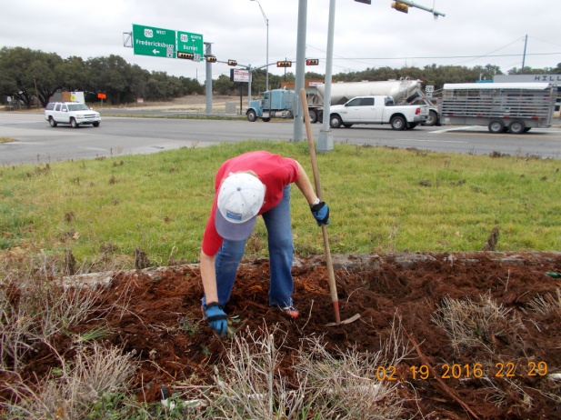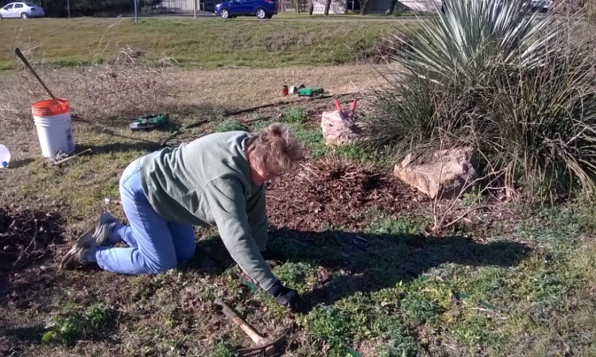
Susan working at Johnson City South sign
Barbara working hard at the “Y”

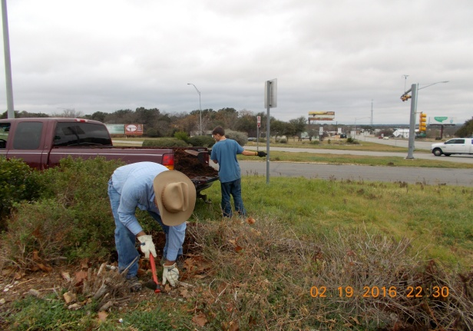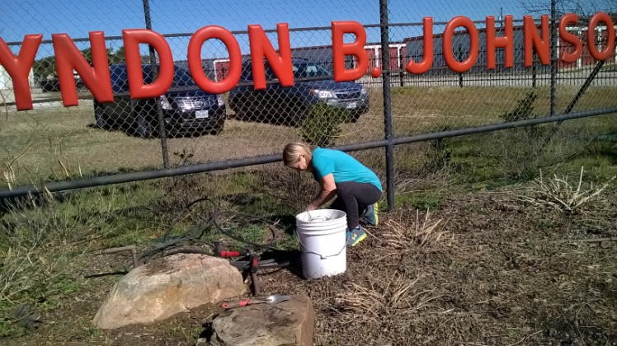
Joan clearing, pruning and planting bluebonnets
Ray preparing the beds for mulch.

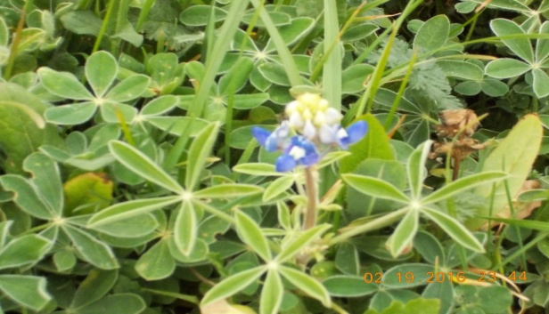
“The first bluebonnet I have seen!!!” Spring!!!!

PLANT IDENTIFICATION
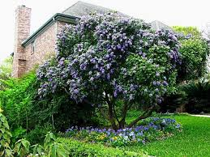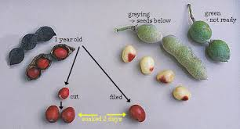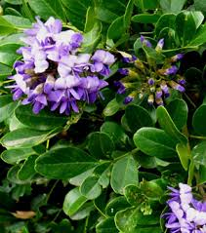
Plant ID : Texas Mountain Laurel

Common Names: Texas Mountain Laurel, Mountain Laurel, Mescal Bean, Frigolito, Frijolillo
Scientific Name: Sophora secundiflora Family: Fabaceae (Leguminosae)
Description: medium to large shrub, trained to a single or multi trunk tree), can grow to 20’
Bark: dark brown to almost black, with thin scales developing into narrow, flat ridges with tight fissures in between
Flower: A dense cluster of purple, pea-like flowers appears with the new leaves in spring, grape smell

Fruit: seedpods, gray with a felt-like surface texture, aging to dark brown, seeds glossy red
Requirements: Full sun, sun to partial shade, drought tolerant, suitable for xeriscaping

Maintenance: minimal, likes dry, rocky, well-drained, preferably calcareous soils.
Local Location: alkaline soil, prefers rocky limestone soil
Wildlife: Butterflies, Bees; Provides roosting and nesting sites for birds
Comments: These red beans were prized by Indians. In fact, Indians believed that a necklace of Mt. Laurel Beans presented as a gift to someone would protect that person from bodily harm. The red beans were so valued as an ornament that they were actually used as Indian currency.
Sources: LBJ Wildflower Center, Texas Native Ornamental Trees by Native Plant Society of Texas, and PlantAnsers.com; submitted by Donna Norris

From the Comal County Gardening Guide:
  - Now is the time to plant most of your spring garden
    - Prepare soil, till in cover crop 2 weeks before planting to allow decomposition
  - Remove spent cool weather vegetables to prevent attracting bugs
  - Plant seeds!! If you did not plant them in February. These include frost-sensitive bush beans, pole beans sweet corn, cucumbers and squash.
  - Plant eggplant, sweet peppers, hot peppers and tomatoes by the 15th (April 1 in the Hill Country)

From the Farmers’ Almanac: March 2016
1st-2nd Barren days, do no planting.
3rd-4th Any root crops that can be planted now will do well.
5th-6th A barren period, best suited for killing plant pests. Do plowing and cultivating.
7th-8th Good for planting cucumbers, melons, pumpkins, and other vine crops. Set strawberry plants. First day is a good day for transplanting. First day is also a favorable day for planting beets, carrots, radishes, salsify, turnips, peanuts, and other root crops. Second day is a good day for planting aboveground crops.
9th-10th Cultivate and spray, do general farm work, but no planting.
11th-12th Favorable for planting crops bearing yield above the ground.
13th-14th Seeds planted now tend to rot in ground.
15th-17th Excellent for sowing seedbeds and flower gardens. Best planting days for aboveground crops, especially peas, beans, cucumbers, and squash where climate permits.
18th-22nd A most barren period, best for killing plant pests or doing chores around the farm.
23rd-24th Fine for sowing grains, hay, and forage crops. Plant flowers. Favorable days for planting root crops.
25th-27th Start seedbeds. Good days for transplanting. Excellent time for planting root crops that can be planted now. Also good for Leafy vegetables.
28th-29th Barren days, do no planting.
30th-31st Any root crops that can be planted now will do well.
