₊
NEXT MEETING:
APRIL 12, 1pm, Johnson City—Methodist Church
April 2016
Volume 21 issue 4

President’s Message 1
Did You Know 1
MG Calendar 2
Upcoming Events 2
Meeting Minutes 3
Hodge Podge 5
“Don’t Take My Word… 6
“Wish You Were Here . . . 8
Plant ID 9
Garden To-Do List 10
Flyers/Notes/Resources 11

Educational programs of the Texas AgriLife Extension Service are open to all people without regard to race, color, sex, disability, religion, age, or national origin. The Texas A&M University System, U.S. Department of Agriculture, and the County Commissioners Courts of Texas are cooperating.

http://www.earthday.org/
President’s Message
Greetings,
Spring has sprung for sure! Our view is green in all directions!! And finally the wildflowers are coming on strong; what a sight to see, they make driving a pleasure!
I am getting positive feedback from folks regarding the blast reminders for workdays. Thanks Donna for keeping up with the blast.
Our last meeting’s speaker was super interesting; he had a lot more than orchids going on for sure! I learned so much about the beautiful exotic plants in his greenhouse, the fragrances were most surprising to me.
Our meeting this month will be open to the public. We will start the meeting at 1p sharp, move quickly through the agenda in order to be ready for the presentation and the public. I hope this will be the first of many presentations for the community.
Plant Sale is set for the 30th of April. We will have several MG setting up demos and information booths. I am sure we will have lots of plants to sell and good times will be had by all.
I thank all of you for your words of encouragement after my surgery. I am feeling a lot better; the cough is gone, now I just have to get back to eating!
Thanks for all your hard work,
Bernadette

Bernadette

DID YOU KNOW…?
Earth Day—April 22 The idea for a national day to focus on the environment came to Earth Day founder Gaylord Nelson, then a U.S. Senator from Wisconsin, after witnessing the ravages of the 1969 massive oil spill in Santa Barbara, California http://www.earthday.org
Arbor Day--April 29 The first Arbor Day took place on April 10, 1872 in Nebraska. It was the brainchild of Julius Sterling Morton (1832-1902), a Nebraska journalist and politician originally from Michigan. Nebraska's first Arbor Day was an amazing success. More than one million trees were planted. http://arbor-day.net/

20—Safety Day; Blanco

NATIONAL GARDEN MONTH!!

Sunday | Monday | Tuesday | Wednesday | Thursday | Friday | saturday
 |  |  |  |  | 1 | 2
3 | 4  Workday at the “Y”  9-12 | 5 | 6 | 7 | 8 | 9  Blooms & Barrels--HCMG
10 | 11 | 12  MG MEETING  JC—Canning!  1:00 | 13  Grass Area @ Settlement | 14 | 15 | 16
17 | 1 Workday at the “Y”  9-128 | 19 | 20 | 21 | 22  Earth Day | 23  Orchid Odyssey
24 | 25 | 26 | 27  Grass Area @ Settlement | 28 | 29  Arbor Day | 30  PLANT SALE!!  JC-

April 9—“Blooms and Barrels” 9am-1pm Kerrville (this is their “gardenscape” event!)

http://www.hillcountrymastergardeners.org/

April 12—Blanco MG meeting, 1:00pm, Johnson City –First United Methodist Church

“Canning 101”

April 23-24—Orchid Odyssey; Zilker Botanical Center, Austin (see flyer at end of newsletter)

April 30—PLANT SALE--

May 17-19—TEXAS State Master Gardener Conference
http://www.ccmgatx.org/txmg2016

May 20—Safety Day; Blanco County Fairgrounds

Master Gardeners of Blanco County
March 2016 Minutes

The March meeting of the Master Gardeners of Blanco County was held at Maddy Vetter’s home in Dripping Springs. President Bernadette McFarling called the meeting to order at 2:24 PM on March 8, 2016 following a program on ”Orchids, and How to Care for Them” by Maddy Vetter.. February’s minutes were approved as written.

President’s Report
President Bernadette McFarling announced that an updated member list is in the works. If you have not provided and/or updated your contact information, please send it to Donna Norris as soon as possible. If you have a project, etc., to present at one of our monthly meetings, please put those details on paper and provide a copy to the Secretary, Margaret Becker, for recording.

Treasurer’s Report
Treasurer Joan Marasek was not in attendance and Bernadette could not open the file with the Treasurer’s report. It will be added at next month’s meeting.

Vice President’s Report

VP Alison Garza was not in attendance due to family illness. Bernadette reminded the group that the home canning program, presented by Comal County MG Lee Franzel, has been moved to our meeting on April 12 and will be open to the public. Refreshment volunteers are needed for this event to be held at the First United Methodist Church in Johnson City at 1 PM on April 12. Carol Rankin is requesting your favorite home canning recipes for a handout she will prepare. Please e-mail them to her.

COMMITTEE REPORTS
The Book Sales Committee, led by Susan Hamm, has plans to begin promoting sales of the 50 books that will be arriving soon.
The Plant Sale Committee chairman said that she has not done anything new on the Plant Sale, but Bernadette McFarling encouraged everyone to get their plants growing for the plant sale on April 30 at the Johnson City Park on 290. Our sale will NOT be held in conjunction with the monthly market day this year. It was suggested that our Specialists present some seminars throughout the day. Pat Owens volunteered for rainwater collection and D’Anne Welch will present a seminar on propagation.

The Gardenscape Committee, is waiting on Blanco High School to set their Homecoming date before finalizing a date for the 2016 Gardenscape. Once a date is set, we can begin to solicit speakers and vendors. The 2015 Gardenscape “FUN”damentals was submitted by Jim Meadows and Carol Rankin to the state for event judging. Awards will be announced and presented at the state convention.

PROJECTS – Current and Past
Susan Hamm mentioned that a former MG member has contributed many books that will be catalogued and available in the library at the Ag Extension office.
Shirley Winslow mentioned being interested in the Blanco County Crabapple Project. She will send out an email to the group and hopes to start recording information on the trees soon. This tree is nearing extinction due to deer. Years ago several members acquired and planted them in an effort to save it. Volunteers are needed to map where the trees are, photograph and measure them. Lighting, soil, and growth rate should be recorded. In addition, new trees should be planted to prevent extinction.

NEW PROJECTS
YMAC Community Garden – Carol Rankin and Debbie Burkhard are seeking volunteers who will join with them to assist in the planning of the YMAC Community Garden. Bernadette suggested that Carol send out an e-mail for helpers.

GENERAL BUSINESS

Maddy Verret presented a flyer to the group about the “Orchid Odyssey” in Austin on April 23-14. See flyer attached at the end of newsletter.

BITS AND PIECES
As there was no further business to discuss, the meeting was adjourned at 3:11 PM. Members were free to tour the grounds of Maddy’s home.
Submitted by Donna Norris

HODGE PODGE

HELP NEEDED!

.
Up-Date on Progress at Grass Area in LBJ National Historical Park

The Grass Area was developed under the leadership of Peggy Welch with supporting art work from Susan Evans. The purpose of the project was twofold.
First, it was a grass identification area for the numerous visitors that make their way along the walking trail. Secondly, it was a teaching/workshop area for the MGs.

The first year the Grass Area was established we had an outstanding program at the Settlement Event Center. A speaker from Texas A & M conducted tours of the Grass Exhibit, Susan Evan's displayed the original, watercolor paintings and a large flight of migrating Monarch butterflies delighted the more than 100 visitors.

As the years have passed MGs have let this outstanding teaching area slip away. Of the 16 grass plots 6 have been restored this spring. Several more still have a strong presence of the original grass but require weeding. The most invasive grass is Johnson Grass which has a strong massive, rhizomal structure. To remove this menace you must remove the rhizomes. It can be done but you must be persist in its removal.

Six of the beds need weeding and then replacement of the lost grass species. Since these are native grasses we will have no problem finding desirable specimens for transplants on our properties.

There is a renewed interest by the park in their prairie grassland. Alex Shane, a resource manager at the park, would like our grass exhibit to coordinate with the adjoining Prairie restoration area he is directing for the park. The weather finally cooperated last year so that a prescribed burn could take place.
Alex has other ideas for enhancing the visitor's experience at a Prairie as seen by early settlers.

A proposal I would like to suggest would be that 16 MG members volunteer for one each of the grass plots. (They are about 4' square.) You would maintain your small, grass area, write a brief description about the grass and then the park would handle the publication of a pamphlet.

Later in the year we could once again have a grass workshop. It is amazing what you can learn by caring for an area. Hands-on-Experience!

Thank you for your consideration, Susan Hamm
AND ALSO:
Diane Matthews a long time member lives in Fredericksburg. She needs someone to work once a week in her gardens. Pete from Blanco Gardens used to work for her. His failing health has left him unable to continue. dm1234@ctesc.net

“BUT DON’T TAKE MY WORD FOR IT”
Book Review By Mary Nabers
The Language of Flowers by Vanessa Diffenbaugh
The Language of Flowers, by Vanessa Diffenbaugh, is a novel about a girl who has bounced around in the foster care system until she is put out into the world at 18. Abandoned at birth, Victoria is not sweet and cuddly and lovable. In fact, she cultivates being unlovable. The story is so well written that it is compelling from page one. What ultimately saves Victoria is her love of flowers, her talent for arranging them, and her desire to teach others to use the right flowers to convey their feelings.
The language of flowers is the unifying thread that runs through the novel and is interesting in its own right. Most of us choose the flowers in our gardens by their beauty, their hardiness, their need of water and care and sun and so on. But The Language of Flowers clues us in to another aspect of flowers: their meaning.
Assigning meanings to various flowers was an outgrowth of the Victorian Age, when young women were so closely chaperoned that conversation about personal matters, particularly with members of the opposite sex, was nearly impossible. Girls gradually began to develop a “meaning” for flowers and the idea grew
Some flowers we admire have negative meanings. For example Anemone means forsaken, and Azalea denotes a fragile and ephemeral passion. A surprise is that Lavender stands for mistrust; the Buttercup for ingratitude, and Clematis for poverty. Foxglove means insincerity and Redbud, betrayal. A surprise to me is that my favorite flower, the scarlet geranium, stands for stupidity! I guess that says something about me.
But most flowers designate good qualities or feelings: Baby’s breath shows everlasting love; Magnolia stands for dignity; Moss, maternal love. A Tulip is a declaration of love, and Sage foretells good health and long life. A Trumpet vine means fame, and stonecrop stands for tranquility.
(continued on next page)
Sometimes meaning depends on the color: red rose is love; white rose, a heart unacquainted with love; pink rose means grace; and a yellow rose means infidelity.
And sometimes one flower can make a complete statement: A Pansy says “Think of me.” A Phlox declares, “Our souls are united.” A Peach blossom confesses, “I am your captive.”Liatris states, “I will try again.” And a camellia goes all the way: “My destiny is in your hands.” A red carnation mourns, “My heart breaks.” A clove speaks volumes: “I have loved you and you have not known it.”
Therefore, if you make a bouquet to give someone and you mix marigolds, sunflowers, and pomegranate, your message is grief, false riches, and foolishness. Throw in a little oleander and your message would be clear: beware.
A better arrangement would be honeysuckle for devotion, ivy for fidelity, daisy for innocence, and chrysanthemum for truth.
Master Gardeners ought to remember the persimmon, which declares, “Bury me amid nature’s beauty.”
Diffenbaugh’s initial source was The Floral Offering: A Token of Affection and Esteem; Comprising the Language and Poetry of Flowers, written by Henrietta Dumont in 1851. Later she consulted The Flower Vase (Miss S.C. Edgarton); Language of Flowers (Kate Greenaway); The Language and Sentiment of Flowers (James D. McCabe); and Flora’s Lexicon (Catharine H. Waterman).
The Language of Flowers is a very readable book: good story, interesting characters, with a bonus of learning that flowers are a means of communication.
April Meeting Refreshments will be brought to you by. . .
Susan Evans Joan Marasek Shirley Winslow Henrietta Smith
Thank you for signing up this month!

“WISH YOU WERE HERE….”
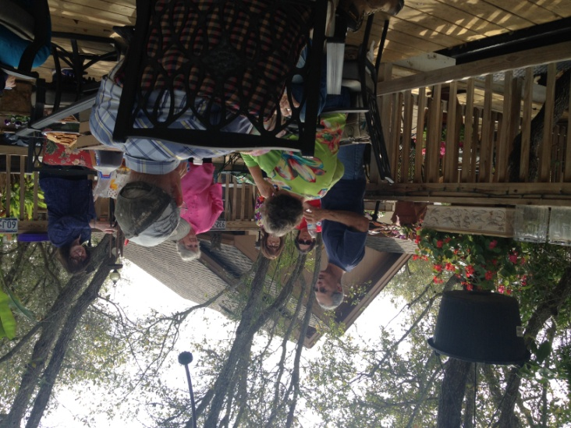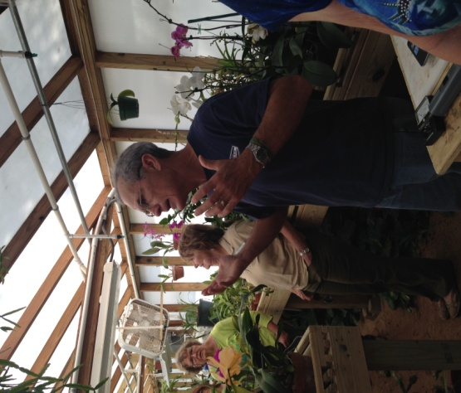
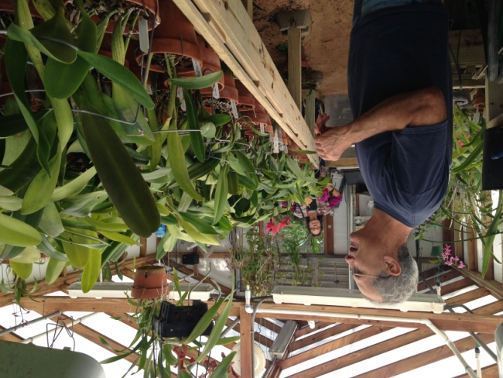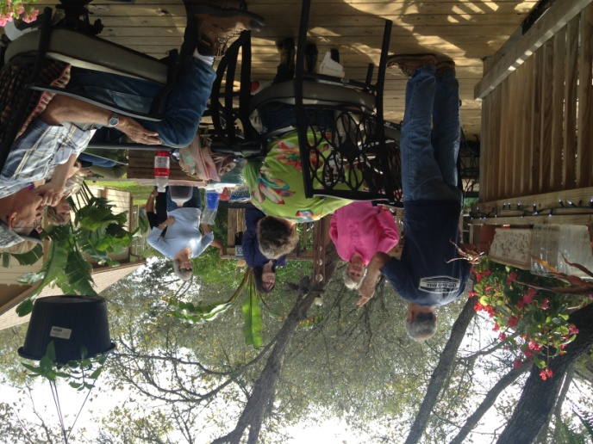
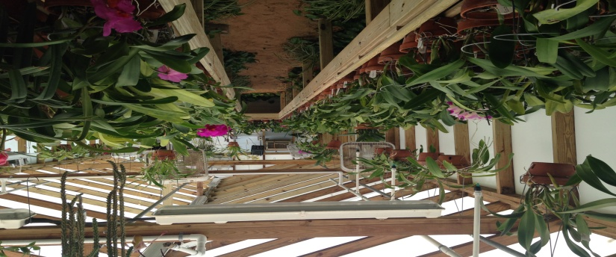
Clockwise from top left: (1) members relaxing on Maddy’s deck during March meeting (2) An explanation of various components used to maintain orchids (3) Preliminary descriptions of various orchid species (Yes that’s D’Anne peeking around the corner) (4) question and answer session before tour of the greenhouse. (5) uninterrupted view of orchid greenhouse

PLANT IDENTIFICATION
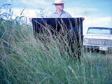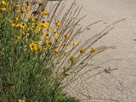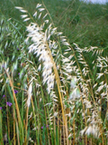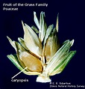
caryopsis
Plant ID : Native Grass—Sideoats grama

Common Names: sideoats grama, Banderilla, Banderita, Navajita
Scientific Name: Bouteloua curtipendula Family: Poaceae (grass family)
Description: Side-oats grama is a bunchy or sod-forming grass with 2-3 ft. stems in erect, wiry clumps. Purplish, oat-like spikelets uniformly line one side of the stem, bleaching to a tan color in the fall.
Leaf: Green, Blue-green, sometimes turning purple or red in fall
Leaf description: alternate, simple, parallel venation

Fruit: caryopsis: a small one-celled, one seeded dry fruit, the typical fruit of grasses and grains
Requirements: sun, part shade, soil moisture:dry, moist, drought tolerant: HIGH

Maintenance: minimal, likes dry, rocky, well-drained, preferably calcareous soils.
Local Location: Prairies; open brush; forest openings; rocky slopes
Wildlife: Butterflies, Birds
Comments:. Sideoats grama is the state grass of Texas. This medium-tall grass mixes well in plantings with spring wildflowers, because it stays short in the spring. Birds love the ripe seeds. In nature, this plant increases rapidly when its site is damaged by drought or grazing.
Sources: LBJ Wildflower Center, Texas Native Ornamental Trees by Native Plant Society of Texas, and PlantAnsers.com;
Submitted by Donna Norris

From the Comal County Gardening Guide:
  - April is the end of ‘spring planting’ for most vegetable gardens
  - MULCH!! This will deter weeds and keep soil from drying out. Use leaves, straw or hay.
  - Monitor your vegetables for aphids, thrips, squash vine borers and stink bugs.
  - FERTILIZE!!vegetables need fertilizer to generate growth after first fruit sets, then every three weeks thereafter.
  - April is prime oak wilt season DO NOT PRUNE OAK TREES NOW!

From the Farmers’ Almanac: April 2016
1st-3rd Excellent time to kill weeds, briars, poison ivy, and other plant pests.
4th-5th Set strawberry plants. Excellent for any vine crops, such as beans, peas, and cucumbers. Good days for transplanting. Favorable days for planting root crops.
6th-7th Poor planting days. Break ground or cultivate.
8th-9th Favorable for planting beans, corn, cotton, tomatoes, peppers, and other aboveground crops.
10th-11th Poor days for planting, seeds tend to rot in ground.
12th-13th Plant seedbeds and start flower gardens. Plant tomatoes, beans, peppers, corn, cotton, and other aboveground crops on these most fruitful days.
14th-18th Grub out weeds, briars, and other plant pests.
*19th-20th A favorable time for sowing grains, hay, and fodder crops. Plant flowers. Plant corn, melons, squash, tomatoes, and other aboveground crops.
21st-23rd Start seedbeds. First day is a favorable day for planting aboveground crops, especially cabbage, cauliflower, lettuce, kale, celery, and other leafy vegetables. Last two days are good days for transplanting. Last two days are also good days for planting beets, carrots, radishes, turnips, peanuts, and other root crops. Also good for Leafy vegetables.
24th-25th Neither plant nor sow on these barren days.
26th-28th Favorable days for planting beets, carrots, turnips, radishes, onions, and other root crops.
29th-30th Excellent time to kill weeds, briars, poison ivy, and other plant pests
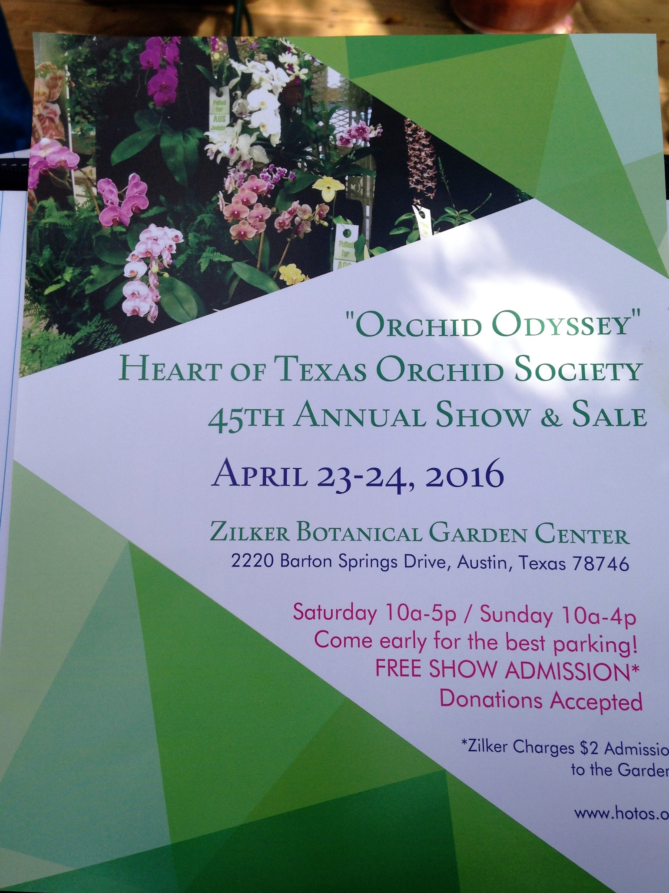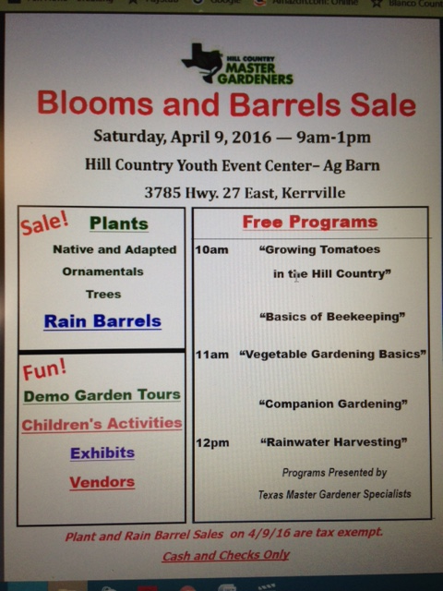
Flyer off HCMG website

Flyer from Maddy Verret

ARE YOU A PUBLISHED WRITER???
Promoting MG Gardening Authors MG Dave Walters, Texas Master Gardeners Association 1st VP for Johnson County, TX, is working on their website. He is trying to promote any and all MG gardening authors who have been published, whether it’s a book or a magazine article. “Not local newspapers...actually published.“ Walters wants to promote sales, and also to encourage all Master Gardeners out there who are so knowledgeable to write about what they love: gardening. He plans to share this information with TMGA Nicky Maddams at Texas A&M AgriLife for the state website. So, if anyone among our HCMG membership fits this criteria and wishes to contact Walters, go to detdbw01@gmail.com. “Happy Digging” Dave Walters
INTERNET RESOURCES (a few, there are hundreds!!)
Aggie Horticulture http://aggie-horticulture.tamu.edu/
Central Texas Gardener, KLRU-TV http://www.klru.org/ctg/
Texas Gardener, the Magazine http://www.texasgardener.com/

