FOR RELEASE CONTACT –Susan Lopez 361 727-0860
October 20, 2008 or Ernie Edmundson 361 790-0103

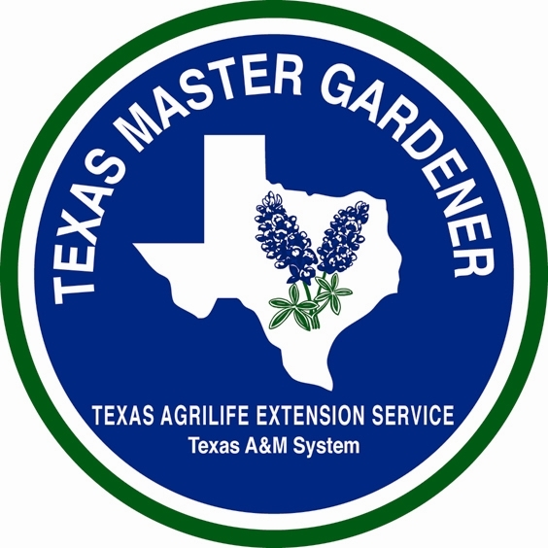

GARDENING WITH

ARANSAS/SAN PATRICIO

MASTER GARDENERS



GROWING OLIVES IN SOUTH TEXAS

By Susan Lopez, Master Gardener, Aransas/San Patricio Master Gardeners
Fruit trees and Texas just seem to go together, from the peach groves of the hill country to the citrus groves of the valley. However, did you know there is another fruit tree that you should consider adding to your list of producers for our area? It is a special fruit tree because it is among the oldest cultivated trees in the world, and its history can be traced back to Biblical times. It is a tree that has been referred to as a symbol of prosperity, beauty and peace, and in ancient Athens it was considered a “gift from the Gods”. I am referring to the Olive Tree – a tree that has been widely feted in both scripture and literature and whose olive oil was used to fuel the first “eternal flame” of the original Olympic Games.
For many years olive growing in Texas was just not tried. It was thought the climate and soil conditions in most of Texas would not support olive production. Today, however, there are olive orchards popping up all over Texas, from Wimberley and Deely, Texas, to a large olive orchard just south of San Antonio where I bought my very own Arbequina olive trees. There are also experimental groves now producing in both Galveston and Seadrift, Texas. The impetus for this growing interest in olive production is due in large part to the ever-increasing demand for olive oil. With the demand for olive oil rising as Texans seek out a healthier diet, olive oil production is becoming a very lucrative business. Plus, olive trees are one of the hardiest and drought-resistant fruit trees, so as water shortage problems continue to evolve throughout Texas, olive trees just make good sense in keeping with the Earth Kind principle of water conservation.
Now that I may have convinced you to either plant your very own olive tree or you may even be thinking olive orchard, here is how you get started.
Soil: Olives do well in almost all soils from sands to clays with a ph range from 5.5 to 8.5. Olive trees do not have a deep root system so they do not need a deep soil, however, the soil must be well-drained. Olive trees do not like wet feet. Nutrients may be added once or twice a year, and normally nitrogen is the only element that may need to be applied, as olive trees are very good at extracting nutrients from the soil. Fish emulsion and manure are also recommended to encourage production.
Climate: Temperature controls growth, reproduction, and survival of the olive. Growth begins after temperatures warm to at least 70 degrees F in the spring and continues until temperatures drop below this point in the fall. The olive tree is very cold-hardy but will sustain damage if exposed to temperatures of 17 degrees F and below. While in South Texas we do not worry too much about temperatures falling in the winter and freezing our trees, our lack of temperature variance might be the limiting factor for olive production, although in research studies it is being learned this lack of temperature variance may not be as impacting as originally thought. Additionally, olive trees are salt tolerant and although it is recommended they be planted in full sun, they definitely seem to have an affinity for oak trees and will flourish if planted just outside the canopy of a friendly oak.
Water Requirements: Olive trees are very drought tolerant and suffer more from over watering than under watering. A drip irrigation with good drainage is the key factor for keeping your olive tree healthy and producing. Misting of seedlings and shoots to encourage their initial growth is recommended.
Planting Requirements: Fall is the best time to plant, or early spring is the second best time. A spacing of at least 18 feet by 14 feet is recommended, although if you have more space, I would allow even more room. Olive trees can get quite large, growing to 30 feet high with a 30 foot spread, but size will vary with the plant selected. Place the tree in a hole the same depth as it was in the pot. Do not disturb its roots. Mix the fill soil with organic matter and add back into the hole. Water thoroughly to help establish the roots, but again make sure soil is well drained.
Plant Selection: While there are a variety of olive trees to choose from, the following varieties are proven producers in South Texas – Mission, Manzanilla, Picual, Pendolino, Arbequina, Arbosana, Koroneiki and Chemlali. While all olive trees possess male and female flowers, some need a pollinator. Barouni and Sevillano will serve as pollinators for Manzanilla. Pendolino is a pollinator for Leccino and Mission, while Koroneiki and Arbosana are pollinated by Arbequina. Chemlali and Arbequina are self pollinating. Olive trees will generally produce fruit within four to five years after planting, but Arbequina, Arbonsana and Koroneiki can be expected to produce fruit within about two to three years of planting. However, as with any tree, transplanting can set back fruit production by a year or two as has been the case with my Arbequina.
Limited space will not allow me to go on and on about the wonderful olive tree, but there is a wealth of information out there on the internet and on websites of individual olive orchards. The following are some helpful websites: Aggie Horticulture - http://aggie-horticulture.tamu.edu/extension/fruit/olive/olive.html , Texas Olive Oil Council – http://www.texasoliveoilcouncil.org/, and Sandy Oaks Olive Orchard – www.sandyoaks.com.
The Texas AgriLife Extension Service - Aransas County Office can be reached by phone at 361 790-0103 or by email at aransas-tx@tamu.edu and is located at 611 E Mimosa, Rockport, TX.
AgriLife Extension education programs serve people of all ages, regardless of socioeconomic level, race, color, sex, religion, handicap or national origin.

