FOR RELEASE: February 4, 2008 Contact: Mary Ann Geer
(361) 758-3577
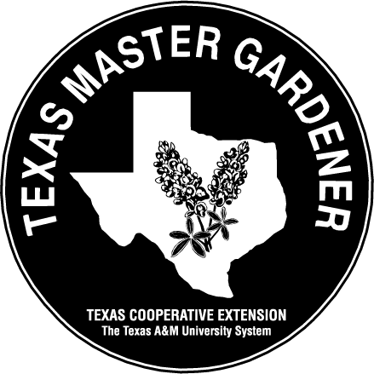

GARDENING WITH

ARANSAS/SAN PATRICIO

MASTER GARDENERS



AVOCADOS – FROM SEED TO TREE

By Mary Ann Geer, Master Gardener, Aransas/San Patricio Master Gardeners

Avocados are a fruit, not a vegetable, belonging to the genus Persea in the Lauraceae family. The avocado is also called an Alligator Pear because of its pear-like shape and green skin. California produces about 90 percent of the nation's avocado crop. There are seven varieties of avocados grown commercially in California, but the Hass is the most popular.

When I was younger, I stuck three toothpicks in an avocado seed and placed it over a glass of water. This seems to be the most popular way to germinate these seeds. Over the years, I have found an easier and more reliable way to germinate the seeds. Place the avocado seed in a wet paper towel and into a sealable clear plastic storage bag. Put the bag in a cool dark place for about three months.

Use as many as four seeds at a time in the bag and check on them every couple of weeks. Some of them will sprout earlier and some won't sprout at all. When the seed(s) have sprouted, plant them in a one-gallon pot using potting soil and place in a shaded place. I have one now in the ground that grew to 38 inches in one year in its pot.

The avocado seeds I have propagated are the California Hass, which has a pebbly skin. A friend in Rockport has a California Bacon that is approximately six to seven years old that is seven feet tall and bore it's first fruit this last season. This variety has smooth skin and a mild taste. That tree is now setting flowers as they do from January to March.

When your avocado trees planted in the ground they need some protection from wind, such as the south side of the house. Avocados will grow in the shade, but are productive only in full sun and may take a number of years to produce.

Contact an Aransas/San Patricio Master Gardener at the Texas AgriLife Extension Service - Aransas County Office, by phone at 790-0103 or by email at aransas-tx@tamu.edu. AgriLife Extension education programs serve people of all ages, regardless of socioeconomic level, race, color, sex, religion, handicap or national origin.

Green Acres Demonstration Garden is located at the AgriLife Extension - Aransas County Office, 611 E. Mimosa, Rockport, Texas. Because of generous community support and the work of volunteer Master Gardeners, the gardens are free. Visit the gardens during daylight hours, seven days a week.

