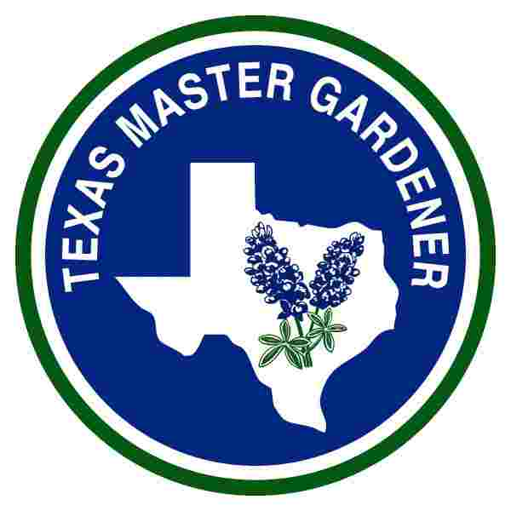
FOR RELEASE CONTACT-Ernie Edmundson 790-0103
August 8, 2011

By Ernie Edmundson, Master Gardener

TOP TEN NATIVE PLANTS FOR ATTRACTING HUMMINGBIRDS
Ruby-throated hummingbirds will soon migrate through our area on their way to their wintering grounds in Mexico and Central America. Everyone loves to watch their antics as they vie for their favorite food to sustain their rapidly beating hearts and wings. They zip and zoom around, fighting for the best spot at the hummingbird nectar feeders.

During the major migration, which runs from mid-August to mid-October, we can all invite the feisty little birds into our yards just by hanging nectar feeders. Generally the more feeders, the more birds will come to our back yards, but there are a couple of other important needs. Trees for resting and roosting at night, and keeping the nectar feeders clean and filled with fresh nectar every two or three days are two important factors that will keep them coming back. Another important factor if you have many trees in your landscape, you may want to post some red banners or flags in the open areas so the hummingbirds can find your yard. Once they find you, they will continue to return to your yard each year. So if you are already doing all that, why do the neighbors still have more hummingbirds in their yard? It could be they have plants hummingbirds prefer for natural nectar. Given a choice, the hummingbirds will pick a flower any day over a nectar feeder. That is why in high rainfall years, fewer birds come to feeders. They are checking out all the native flowers blooming all over the area. The tiny wonders glean not only nectar but also insects, a major portion of their diet, from local native plants. In exchange for the nectar and insects, hummingbirds return the favor by pollinating the flowers that they visit.

You can attract hummingbirds to your landscape, not just during the fall migration, but all through the year, by planting their favorite nectar producers. There are many native plants from which to choose that have the trumpet-shaped nectar-filled flowers in colors of red, orange, pink, yellow, blue, or purple. Plant some of the best native hummingbird plants for local gardens.

Number one on the list is Turks Cap, Malvaviscus drummondii, a hibiscus that is a primary food source for migrating hummingbirds. Scarlet blooms summer through fall look like miniature turbans, and are filled with nectar. This small semi-evergreen shrub two to four feet tall grows well in dry to moist sandy or clay soils and is often found growing tucked under the shade of live oaks or on sunny salt flats close to the bays.

Many salvias are winners in a hummingbird’s eyes with their rich nectar and easy care, also appealing to any gardener. Scarlet Sage, Salvia coccinea, also known as Tropical Sage is a perennial salvia that grows up to three feet tall in dry shade to full sun. Its scarlet red flower spikes attract hummingbirds spring through fall. A bed of scarlet sage can be maintained as a ground cover by trimming periodically. A garden cannot have too much scarlet sage to feed the hummers and it obliges by reseeding readily so gardeners have a constant supply of new plants.

Mealy Blue Sage, Salvia farinaceae, is an evergreen perennial that can reach three feet tall bearing blue flower clusters spring through fall. It thrives in low water spots in sun or part sun. ‘Henry Duelberg’ is a drought tolerant selection that was found growing without any care in a Central Texas cemetery. It should be cut back periodically to allow new growth from the bottom.

The very popular ‘Indigo Spires’ Salvia, is an evergreen perennial hybrid of Mealy Blue Sage and another Texas native Salvia longispicata. “Indigo Spires’ sports long purple flower spikes spring through fall, spreading to six feet wide and up to three feet tall. It requires medium water and partial sun in our hot and dry south Texas summers.

Cenizo, also called Texas Sage, is a sun-loving dry garden plant surviving without rain for months on end and then blooming profusely with lavender or white flowers following a rain. Cenizo, Leucophyllum frustescens, is an evergreen, or ever-grey, shrub reaching up to eight feet tall. Several selections of the species offer smaller overall size such as ‘Silverado’, or greener leaves ‘Green Cloud’, and profuse blooming.

Crossvine, Bignonia capreolata, is an evergreen vine that sports a profusion of large orange and gold trumpet shaped flowers in the spring. Growing in low to medium moisture, sunny or shady areas, and rich soil areas, it has a mannerly behavior climbing into trees for its support.

Coral Bean, Erythrina herbacea, is a prickly deciduous shrub that grows throughout the area in woods or in open areas in dry to moist sand or clay soils. If not cut back in the early spring, it can reach up through the trees to ten feet tall. Gardeners shouldn’t hesitate to prune it to the ground in very early spring. Clusters of red trumpet shaped flowers feed hungry spring-migrating hummingbirds. Twisted seedpods follow flowering with attractive pods of coral-red poisonous seeds. If pets or children tend to eat plants from the landscape, the seedpods should be removed.

Coral Honeysuckle, Lonicera sempervirens, is an evergreen mannerly vine native to southeast Texas and can climb to twenty feet in sunny locations, though it will grow in partial sun. It bears trumpet flower clusters spring through fall inviting the hummingbirds in, followed by fruit relished by other birds.

Butterfly Weed, Asclepias tuberosa, can reach three feet tall in partial or full sun with orange flowers spring through fall never failing to attract hummingbirds, as well as butterflies. Its foliage provides food for hungry monarch and queen butterfly caterpillars. Tropical Butterfly Weed, Asclepias curassavica, from Mexico and Central America is similar, with orange and gold flowers and just as attractive to hungry hummingbirds and is usually more readily available in local nurseries.

Esperanza, Tecoma stans, a south Texas perennial sun-loving shrub grows to ten feet tall with clusters of yellow trumpet shaped flowers spring through fall. Its low water requirement makes it a prime candidate for our climate. The ‘Gold Star’ selection blooms most profusely and can be found in local nurseries.

So start planting any of these native hummingbird favorites to guarantee lots of visits to your garden when these dynamo birds come passing through.

The Texas AgriLife Extension Service - Aransas County Office can be reached by phone at 361 790-0103 or by email at aransas-tx@tamu.edu and is located at 611 E Mimosa, Rockport, TX. For more local gardening news, visit the Aransas/San Patricio Master Gardener website www.aspmastergardeners.org AgriLife Extension education programs serve people of all ages, regardless of socioeconomic level, race, color, sex, religion, handicap or national origin.

