FOR RELEASE CONTACT – Linda T. Collins 361 729-6037
December 22, 2008 or Ernie Edmundson 361 790-0103

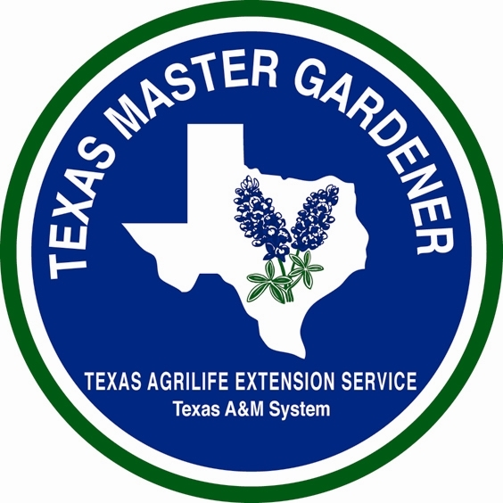

GARDENING WITH

ARANSAS/SAN PATRICIO

MASTER GARDENERS



DECEMBER, CHRISTMAS AND WINTER HOLIDAY HERBS

By Linda T. Collins, Master Gardeners Aransas/San Patricio Master Gardeners

Over the years, I have done some research on December, Christmas and Winter Holiday Herbs, and here is just a little information that found about the meaning of some of these holiday herbs.

December Holiday Herbs and Their Symbolism

- Basil Ocimum basilicum - Love and good wishes, herbs of kings
- Bay Laurel Laurus nobilis - Glory, reward of merit
- Boxwood Buxus sempervirens - Constancy, stoicism, constant love
- Cedar Cedrus, fir Abies, juniper Juniperus, spruce Picea abies - Living presence of the Holy Spirit, prayers ascending
- Costmary Tanacetum balsamita - Bible Herb, Herbes Sainte-Marie, fidelity
- Cypress Cupressus sempervirens - Longevity, eternal life, mourning
- Everlastings Helichrysum (Celosia, Globe, Statice, Amaranth, Strawflower) - Life everlasting
- Holly Ilex - Reminder of the crown of thorns
- Ivy Hedera - Reminds us by its habit of clinging to a strong wall of our human frailties in need of divine support
- Marigold Tagetes - Mary's plant, friendship flower
- Marjoram Origanum marjorana and Oregano Origanum vulgare - Joy, happiness, kindness
- Mint Mentha - Lady's mint, eternal refreshment, wisdom, virtue
- Mistletoe Viscum - Eternal life springs forth in the midst of seeming death
- Myrtle Myrtus communis - Love, dedicated to Mary, symbol of virginity
- Parsley Petroselinum crispum - Mary's little finger, festivity, feast
- Pennyroyal Mentha pulegium - Manger herb, flee away
- Pine Pinus - Longevity, eternal and vigorous life, friendship
- Pot Marigold Calendula Officinalis - Mary's Gold
- Rose Rosa - Purity, God's love expressed
- Rosemary Rosmarinus officinalis - Mary's tree, remembrance, love, friendship, loyalty
- Rue Ruta graveolens - Herb of grace, virtue, banishes evil
- Sage Salvia officinalis - Immortality, health, happiness
- Santolina Santolina chamaecyparissus - Great virtue, avoids evil
- Statice Limonium sinuatum and Globe Amaranth gomphrena - Life everlasting
- Thyme Thymus - Bravery, a manger herb
- Winter Savory Satureja montana - Interest, spiciness, manger herb
- Wormwood Artemisia absinthium - Life everlasting, absence
- Yew Taxus -Penitence, sorrow, sadness

LINDA’S SAUSAGE STUFFING

1 16-ounce package corn bread stuffing or make homemade corn bread
1 ½ cups canned chicken broth
14-16 ounces sausage of your choice (I use Jimmy Dean’s sage or hot sausage)
8 tablespoons butter
1 ½ cups chopped sweet yellow onion
¾ cup chopped celery
¾ cup chopped leeks
¾ cup chopped fennel bulb
4 garlic cloves, chopped
¾ cup nuts of your choice or can add and/or substitute with chopped water chestnuts
½ cup raisins or dried currants or dried cranberries
Salt and Pepper
2 large eggs beaten

Preheat oven to 350°. Butter 13 x 9 x 2 inch glass baking dish. Mix corn bread stuffing and chicken broth in a large bowl. Set aside. In a large heavy skillet brown sausage until cooked. Drain and transfer sausage to the bowl with the stuffing. Drain off fat in skillet. Melt the butter in the same skillet over medium heat. Add onion, celery, leeks, fennel and garlic to skillet and cook until tender. Transfer to bowl with the stuffing. Mix in nuts and fruit and season mixture with salt and pepper. Then add beaten eggs and mix. Be sure not to have the mixture to hot when you add eggs or the eggs will cook. Transfer beaten mixture to the baking dish. Cover dish and bake about 45 minutes. Uncover and bake another 10 minutes or until the top is golden and crisp.
From Coastal Bend Cuisine, compiled by Aransas/San Patricio Master Gardeners. With over 450 recipes, this local cookbook makes a great last minute gift. Cost is $15.

The Texas AgriLife Extension Service - Aransas County Office can be reached by phone at 361 790-0103 or by email at aransas-tx@tamu.edu and is located at 611 E Mimosa, Rockport, TX.

AgriLife Extension education programs serve people of all ages, regardless of socioeconomic level, race, color, sex, religion, handicap or national origin.

