FOR RELEASE CONTACT – Winnie Trippet 361-727-1492
October 29, 2007
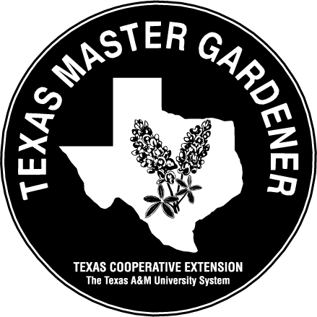

GARDENING WITH THE MASTER GARDENERS,

TEXAS COOPERATIVE EXTENSION

Rainwater Harvesting a Historical Perspective

By Winnie Trippet, Master Gardener, Aransas/San Patricio Master Gardeners

To learn more about the subject of Rainwater Harvesting, join Ms. Trippet along with Master Gardeners Cathy Brock and Frankie Fox for a free Brown Bag presentation on Thursday, November 8, 2007 at the Aransas County library, 701 E. Mimosa, Rockport, from 12- 1:30 pm.

Rainwater collection systems have been in use for thousands of years throughout the world. Cisterns are mentioned several times in the Old Testament and continue to be used around the world as a means for man to harness a bit of nature for his use. Collection and storage of rainwater has allowed man to live and cultivate land which was previously uninhabitable and unusable without water.

Texas has a long history of rainwater collection originating with natural rainwater catchments in rocks like those at Hueco Tanks State Park near El Paso. This site has several natural cisterns known as tinajas, with evidence of use over the last 10 000 years. Tinajas are natural crevices and depressions in rocks that catch and hold water from rainfall. This source of water in the dry west was so reliable a station for the Butterfield-Overland Mail line was built here in the 1850s.

One of the first things that many settlers built as they moved west were cisterns to provide a reliable source of water that was necessary for survival. All over Texas you can see the remains of above ground systems and the tops of below ground tanks that were in use in the 19th century. Above ground cisterns were usually round, taking advantage of the inherent strength of circular structures and made of concrete, rock, wood or metal, each having its drawbacks.

Underground cisterns resemble a dug well but were cone or bell shaped, wider at the bottom than at the top. A hole was dug 8-10 feet wide and 10-12 feet deep. It was floored and walled with rock or concrete with the walls narrowing until the surface of the ground was reached. Dirt was filled in around the cistern leaving an opening above ground large enough for a bucket and pulley system to remove water. These cisterns were fed from the gutter system on the roof of the house. Many homes had cisterns and wells, the well water was used for livestock and washing while the rainwater was used for cooking and drinking.

In our area the Fulton Mansion, built in 1874-1877, serves as an example of a home that relied on rainwater collection for its water. No longer functioning, many of the remnants of the system are still visible as described on an interpretive panel on one of the basement windows. As you can see from the sketch, this was quite an elaborate system.

In the late 19th and early 20th centuries, as technologies improved and more people settled in urban areas, most Texans began relying on well water and municipal water supplies. Well drilling evolved from a hand dug operation to equipment that could drill a 500 foot water well in a matter of days. As municipal water systems became more prevalent it just became easier to turn on the tap and rely on the public sector to supply water than to maintain an independent water system.

Now, in the 21st century there has been a renaissance of rainwater collection here in Texas. This has been brought on by drought, water shortages, questionable water quality and increasing costs both environmental and economic associated with large municipal water systems. As a historically proven alternative water source, rainwater harvesting is making a strong come back here in Texas.

Visit the Aransas County Extension web page aransas-tx.tamu.edu. for a link to additional Rainwater Harvesting information. For other information or questions about local gardening, contact an Aransas/San Patricio Master Gardener at Aransas County Texas Cooperative Extension, by email at aransas-tx@tamu.edu, by phone 790-0103, or Mondays through Fridays from 8 a.m. until 5 p.m., at 611 East Mimosa, Rockport. Extension education programs serve people of all ages, regardless of socioeconomic level, race, color, sex, religion, handicap or national origin.

Green Acres Demonstration Garden is located with the Aransas County Extension office. Because of generous community support and the work of volunteer Master Gardeners, the gardens are free. Visit the gardens during daylight hours, seven days a week.

