

**Sep 20 - Tuesday**

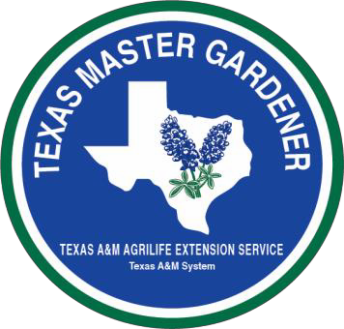

**Agenda**

7:30 - 8:00 Registration

8:00 - 8:15 Welcome – David Rodriguez, County Extension Agent-Horticulturist

8:15 - 8:20 Welcome – Nelda Speller, County Extension Director, Bexar County

8:20 - 8:45 Introduction – Student Introduction

8:45 - 9:30 What is the Texas Superstar Program – What it takes to become a Texas Superstar Plant.

Where to find information on Texas Superstar Plants

The New Texas Superstar Brochure

Dr. Brent Pemberton, Professor, Overton Research & Extension Center, Texas A&M Research, Overton, TX

9:30 – 10:00 How and Why the Texas Superstar Program started.

Dr. Jerry Parsons, Retired, Texas A&M AgriLife Extension Service, Extension Horticulturist

10:00 – 10:10 Break

10:10 – 11:00 The Colorization of the Texas Bluebonnet.

- Texas Bluebonnet

- Texas Maroon Bluebonnet

- Lady Bird Johnson Royal Bluebonnet

- Others Colors

11:00 – 11:10 Break

11:10 – 11:45 Texas Superstar Vegetables: Tomatoes and Broccoli.

Tomato Selections: Surefire, Tycoon , and BHN-968

Building Partnerships with cooperators

The Rodeo Tomato and conducting trials

Rio Grande Gold Pepper

Dr. Jerry Parsons

11:45 – 12:00 Fall zinnias and Mari-mums, Purple Flash Ornamental pepper and ‘NuMex Twilight’ pepper

David Rodriguez

12:00 – 12:45 Lunch provided (Visit Bexar County Master Gardener -Sir Oliver ‘Smitty’ Smith, Texas Superstar Plant Specimens)

12:45 - 1:50 Texas Superstar: Annuals - Part I

- Whopper begonia

- Brazilian Red Hots alternanthera

- Angelonia or Summer snapdragon

- Baby’s Breath euphorbias and Cool Season euphorbias

- Globe Amaranth

- Dakota Gold helenium

- Rio Series mandevilla

- Tidal Wave Silver petunias and Cherry petunias

- Caricature plant

Dr. Brent Pemberton

1:50 - 2:00 Break

2:00 - 2:45 Texas Superstar: Annuals - Part II

- Larkspur

- Laura Bush petunias

- Butterfly Deep Pink pentas

- Vinca Cora series

Dr. Jerry Parsons

2:45 - 3:00 Texas Superstar: 2015 Annuals

White Stream lobularia and Little Ruby alternanthera

David Rodriguez

3:00 - 3:10 Break

3:10 - 4:00 Texas Superstar Trees: Chinese Pistache, Texas Lilac vitex, Possumhaw holly, Lacey oak, Shantung maple, Chinkapin oak and Basham’s Party Pink crape myrtle.

Mark Peterson, Conservation Project Coordinator, San Antonio Water System

4:00 - 5:00 How Texas Superstar plants are distinguish from other plants.

How to find the best plants on a local level and the importance of supporting Independent Nurseries. John Fanick Phlox and other plants named after Fanick family.

Mark Fanick, co-owner of Fanick’s Garden Center

**Sep 21 - Wednesday**

**Agenda**

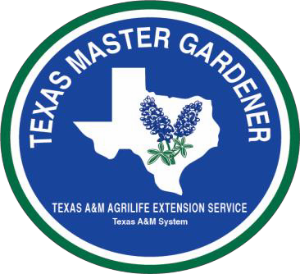

8:00 - 9:20 Texas Superstar: Fruit Satsuma Mandarin Oranges for the Landscape or Patio Natchez Blackberries

Other Fruit Candidates: Pomegrate and Olives

Dr. Larry A. Stein, Associate Department Head/Extension and Extension Specialist, Uvalde, TX

9:20 - 9:30 Break

9:30 - 11:30 How we find Texas Superstar Plants.

Texas Superstar: Perennials

- Texas Gold columbine

- New Gold lantana and Trailing Purple lantana

- Turk’s Cap

- Dwarf Mexican petunia

- Fanick’s phlox and Victoria phlox

- Mexican Bush sage

- Henry Duelberg salvia and Mystic Spires Blue salvia

Greg Grant, Horticulturist, Stephen F. Austin State University, Austin, TX

11:30 – 12:00 Landscape Considerations of Texas Superstars

Greg Grant

12:00 - 1:00 Lunch (Book signing with Greg Grant)

1:00 - 1:50 Texas Superstars: Roses

- Belinda’s Dream

- Grandma’s Yellow

- Knockout

- Marie Daily

Greg Grant

1:50 - 2:00 Break

2:00 - 3:00 Texas Superstar: Per-Annuals

- Firebush

- Gold Star esperanza

- Pride-of-Barbados

- Duranta

- Compact Spicy Jatropha

- Blue Prince verbena

Greg Grant

3:00 - 3:10 Break

3:10 - 4:00 Texas Superstar: More Plants

- Moy Grande hibiscus and Flare hibiscus

- Cape Plumbago

- Blue Prince verbena

- Thyrallis

- Variegated Tapioca

- Moth Orchid

Dr. Jerry Parsons

4:00 - 5:00 Texas Superstar: Water Lilies

Shane Stefek, President, Water Garden Gems, Marion, TX

6:00 pm Networking Dinner Provided

Site T.B.A.

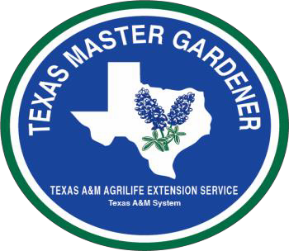

**Sep 22 - Thursday**

8:00 - 12:00 Tour at San Antonio Botanical Garden, 555 Funston Pl, 210 207-3250

Welcome by Bob Brackman, Director, San Antonio Botanical Garden

- Tour conducted by David Rodriguez and Master Gardener Lou Kellogg

Will walk garden and look at established Texas Superstar plants.

- Tour the Children’s Vegetable Garden

NOTE: Everyone will meet at the front entrance of the San Antonio Botanical Garden (555 Funston Place) Expect to walk so bring along a hat, sunglasses, comfortable clothing and shoes. Bring a notebook for notes and a camera, if you like.

Texas A&M AgriLife Extension Service

3355 Cherry Ridge, Suite 208 EAST COURT

San Antonio, TX 78230-4818

210 631-0400

South IH-10 North

Texas A&M AgriLife Ext Svc

3355 Cherry Ridge, Suite 208  
 EAST Court

Cherry Ridge Drive

Briaridge

W  410 E