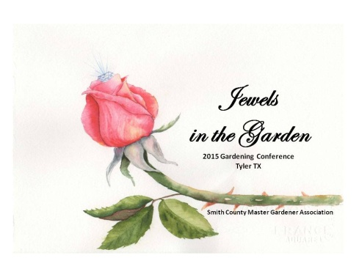
Mark your calendars and join us
The Smith County Master Gardeners (Texas) are hosting a special one day conference
Jewels in the Garden
June 6, 2015
The conference will highlight noted garden speakers featuring four presentations
Nicholas Staddon – Director of New Plants, Monrovia CA
Tom LeRoy – Horticulture Agent, Montgomery Co. TX-retired
Steve Huddleston – Director of Fort Worth, TX Botanic Garden
Lunch will be included as well as an opportunity to shop local vendors.
Tours of the four gardens designed and maintained by the Smith County Master Gardeners, located within the famous Tyler Rose Garden, will follow the program
Registration, scheduling, and lodging information can be found on our website
http://txmg.org/smith/jewels/

