FOR RELEASE CONTACT – Elayne Arne 361 790-5456
Aug 11, 2008 or Ernie Edmundson 361 790-0103
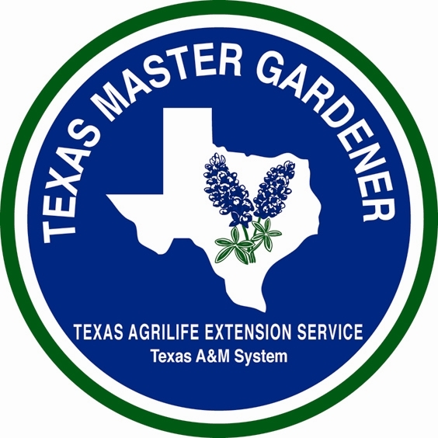

GARDENING WITH

ARANSAS/SAN PATRICIO

MASTER GARDENERS


PLANTS AND YOUR ALLERGIES

By Lou Harris and Elayne Arne, Master Gardeners, Aransas/San Patricio Master Gardeners

Molds are microscopic fungi. They are related to mushrooms but have no stems, roots or leaves. Their spores float in air like pollen and are present all year long throughout the south and on the west coast. They generally reach their peak in July in warm climates; in colder states, the peak is in October. Unlike pollens, molds are not a seasonal allergen, meaning molds spores are around whenever the weather conditions such as wind, rain and temperature are right. Molds are everywhere outdoors – in soil, vegetation, rotting wood and leaves. They can find homes indoors in attics, bathrooms, refrigerators, garbage containers, damp houseplant soils, carpets and upholstery.

Pollens are the tiny, egg-shaped male cells of flowering plants that are necessary for plant fertilization. Pollen production is seasonal in nature with the pollen season starting later in the spring as one moves north. In southern states, pollen season can begin as early as January and it generally lasts from February or March through October. Trees are the earliest pollinators (live oaks are at peak pollen production here in March). Generally tree pollen season ends about May but in May, grass pollens take the next cycle until about mid July. Examples of pollinating grasses are: Johnson, timothy, Bermuda, orchard, sweet vernal, red top and some blue grasses. After the grasses have had their way with your sinuses, weeds pollinate from late summer until fall, examples are: ragweed, sagebrush, pigweed, tumbleweed, Russian thistle and cockleweed.

There are two basic types of pollen – one is light and depends upon the wind to move it to a female plant. The other is heavier and stickier, relying upon insects exploring the flowers for fertilization. The large pollen plants usually have large and colorful flowers that are attractive to insects (and small birds such as hummingbirds). Some plants are self-fertile with very little pollen transmission occurring.

Each plant has a period of pollination that is about the same every year but weather conditions along with size of the pollen can dramatically affect the amount of pollen in the air at any one time. Allergy symptoms are usually minimal on days that are rainy, cloudy or windless. Hot, dry, windy weather means much more pollen and mold distribution. Clouds of pollen can follow wind currents and travel great distances. Ragweed samples have been collected 400 miles out to sea and two miles up in the air. Heavier pollens, such as pine, are less likely to travel far but can drift heavily to the ground and in the immediate area. Although, there is generally less wind in morning and late afternoon, pollen is usually emitted in mornings between 5-10 a.m. and concentrations can be high in the morning.

If you are sensitive to pollens and are choosing flowers for indoor arrangements, select flowers with larger blooms. Daffodils, hydrangeas, lilies, tulips, dahlias and roses are considered more “allergy friendly” based upon pollen size. While you cannot control the winds outdoors, if you are sensitive to pollens, choose female plants over male pollinators. Many cities embarked upon large-scale plantings of male trees over the years to minimize the fruiting or seed “mess” associated with female trees. Some urban areas may now be especially pollen dense due to these policies that sometimes include ordinances forbidding the planting of female varieties of certain plants. For more on this subject, and lists of “low allergen” plants, the book, “Allergy-free Gardening: the Revolutionary Guide to a Healthy Landscape”, by Thomas Ogren is recommended by Galveston County Master Gardener, Cynthia W. Mueller.

The American Academy of Allergy, Asthma and Immunology (AAAAI) website www.aaaai.org has these additional suggestions for those prone to pollen and mold reactions:

DO keep windows closed, especially at night. Air conditioning cleans, cools and filters the air. Keep car windows closed while traveling.
DO minimize early morning activity between 5-10 a.m. when pollen is usually emitted. Try to stay indoors when pollen count or humidity is high or on windy days when dust and pollen are blown about.
DO take a vacation during high pollen season and head for a more pollen free area such as the beach or sea.
DO take allergy medications as prescribed and in the recommended dose.

DON”T take more medication than recommended
DON’T rake leaves or mow lawns or be around freshly cut grass, mowing stirs up pollens and molds; raking stirs up molds.
DON’T hang sheets or clothing out to dry as pollens and molds may collect on them.
DON’T grow too many or overwater houseplants as wet soil encourages mold growth.
The National Allergy Bureau (NAB) is the only pollen and mold counting network that is certified by the AAAAI. Data is reported three times a week. However, the AAAAI cautions that for a variety of reasons, the use of pollen counts in predicting severity of symptoms in a given individual is somewhat limited.
The Texas AgriLife Extension Service - Aransas County Office can be reached by phone at 361 790-0103 or by email at aransas-tx@tamu.edu. AgriLife Extension education programs serve people of all ages, regardless of socioeconomic level, race, color, sex, religion, handicap or national origin.

